Battle of the Ia Drang Valley
Tenets of Air Land Battle Analysis

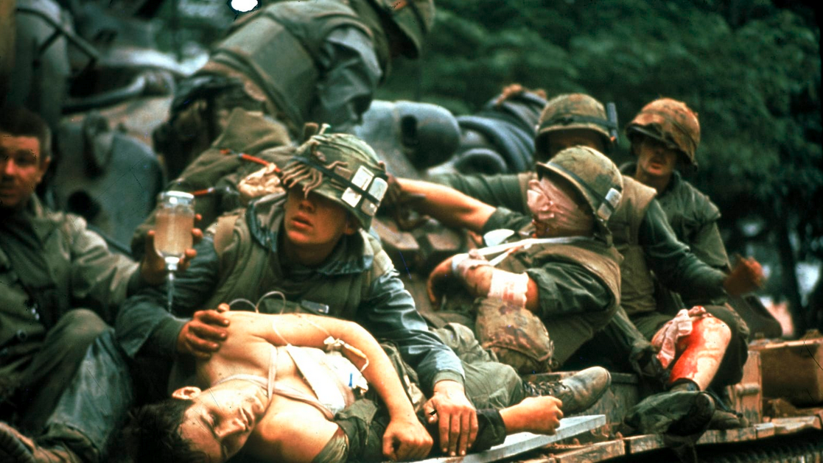

The battle of the Ia Drang Valley [IDV] was actually of series of engagements between the US 1st Cavalry Division and the B-3 Front, North Vietnamese Army from 18 OCT to 24 NOV 1965. Many considered it to be the US Army's 1st battle in Vietnam. It was certainly the first battle between a U.S. division operating under field force headquarters and 3 NVA regiments (the 32d, 33d and 66th) operating under a front headquarters. It may also have been the last battle between NVA and US forces of equivalent size.

The IDV is the valley through which the river (Ia) Drang flows and is drained by the Ia Drang, Ia Puck and an extensive network of small streams flowing west and southwest across the Cambodian border into the Mekong River. The battlefield area covered 1,500 square miles of what appeared to be flat rolling terrain dominated by the Chu Pong Masaif, of rugged mountain 730 meters above sea level, in the southwestern corner of the area of ops (TO), straddling the Cambodian-Vietnamese border. The only passable roads traversed the eastern and northern fringes of the TO. Much of the valley was covered with thick jungle vegetation and trees as high as 100 feet. Even the "open" areas had shrubs and trees over 6 feet high. The sudden mists offered of sinister aura, where daily heat and nighttime cold kept you perpetually and increasingly on edge. The area was eerie - imagine the "Valley of Death," and you picture the Ia Drang.

In this area, particularly at the base of the Chu Pong Masaif, the NVA had built a base camp sanctuary that was unknown to US forces and untouched by Army of the Republic of Vietnam (ARVN) forces. The primary NVA forces operating in this area were the B-3 Front commanded by Gen'l Chu Huy Man, with 3 regular regiments supported by local VC battalions as well as front-level mortar and anti-aircraft units. Each maneuver regiment numbered about 2,200 frontline infantrymen and sappers. Their primary weapon was the Soviet AK47 assault rifle.

The 32d and 33d NVA regiments were veteran fighters against the ARVN and General Man was of veteran of the 1st Indochinese War against the French. These units had been in the valley since early September, rehearsing, developing ambush sites, and pre-positioning and stockpiling ammunition, medical supplies and food. Their tactics were quite simple. Their 1st ploy was to "lute and ambush." They would attack of small outpost or ARVN force and maintain pressure on it with one unit, while another unit waited in well-prepared positions to ambush the relieving force. Their other tactic was called "hugging"; that was to get as close to the opposing force as possible and rely on close-in, almost hand-to-hand fighting to negate their opposing force's firepower advantage. They generally liked to fight at night and rehearsed at night before conducting ops. They always planned and rehearsed an organized withdrawal and would counterattack or leave stay-behind forces to permit an orderly withdrawal. The troops were highly disciplined, with excellent morale and esprit de corps, well fed, well supplied, and in excellent physical condition. Although Man expected to fight tanks with his light infantry, his forces had not fought Americans.

The Americans they would soon meet were in the US 1st Cavalry Division (Airmobile), commanded by Major Gen'l Harry Kinnard. The 1st Cavalry Division had been training for 2 years as the 11th Air Assault Division at Fort Benning under Kinnard's direction. This new Army division was well trained and equipped upon activation as the 1st Cavalry Division (Airmobile) on 1 JUL. It arrived in Vietnam in increments during August and September 1965. The division had 3 brigade headquarters, 8 infantry battalions, an air cavalry squadron, an aerial rocket artillery battery, 3 direct support artillery battalions, an aviation company and the normal combat support and combat service support associated with the Reorganization Objective Army div'n. The division was authorized 10,000 troops, 435 helicopters, basic infantry weapons (M-16 rifle, M60 machinegun and M79 grenade launcher) and state-of-the-art communications equipment. This was clearly the US Army's "high tech" division of the 60s.

The 1st Cavalry had some problems when ordered to deploy; it had 2,700 men not eligible for deployment. The division lost hundreds of pilots, crew chief and mechanics who could not easily be replaced in 1965. Additionally, the troops were issued the M-16 rifle only 10 days prior to departure and had a hurried familiarization with this new weapon. After arriving in country, the division was struck with of peculiar strain of malaria for which there was no known treatment at the time, costing 1,000 additional losses. And although well trained in airmobile tactics, the division had not trained for jungle-type warfare. However, by 9-28-65, the division was in its base camp at An Khe, less than 90 days after activation.

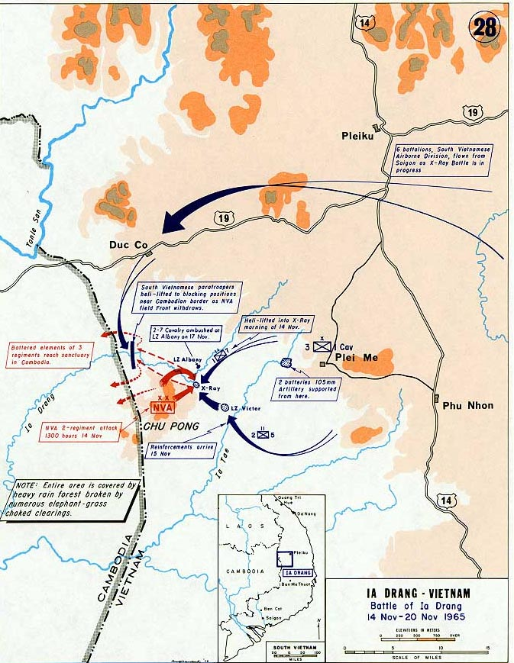

The initial mission of B-3 Front at the operational level was to cut South Vietnam in half. Operationally, it would defeat South Vietnamese and US forces that were in the way. The 1st phase of the plan was to put pressure on of Special Forces camp with one regiment; then to defeat the anticipated relief forces in detail, expecting them to be employed piecemeal. This 1st phase failed miserably when an ARVN relief column was employed in force with tanks and armored personnel carriers, fully supported by US air and artillery, the "luring" force (33d Regiment) was seriously reduced by tenacious fighting on the part of the dependents coupled with American close air support. The "ambushing" force (32d Regiment) was also defeated by the strong relief column. Man was forced to withdraw and to determine how to reap some success (at least psychologically) from this initial failure.

Since there were insufficient ARVN forces to exploit their success, General William Westmoreland made the extremely risky decision to employ the 1st Cavalry Division on of classic exploitation and pursuit mission against what appeared to be two battered NVA regiments withdrawing to Cambodia. The 1st Cavalry's mission was to search and destroy - find the 32d and 33d regiment and kill or capture as many as possible before they reached any sanctuary. The stage was set for the US Army's first battle of the Vietnam War.

NVA General Man withdrew to his well-developed sanctuary in the Chu Pong Masaif. Here he regrouped, reorganized, reequipped and rested his troops, while he waited for the arrival of the fresh 66th Regiment and additional artillery and anti-aircraft units. His new mission was relatively simple. First he was to destroy the much more lucrative Plei Me camp - now reinforced with more than 1,000 ARVN troops and many US advisers. Then he could return to North Vietnam a victor, with a better feel for how the Americans would support his war. In this planning phase, Man's thought process can be examined in relation to the four tenets of Air land Battle as defined in the 1986 edition of US Army Field Manual (FM) 100-5, "Operations":

- Initiate. "Setting or changing the terms of battle by action." Certainly, Man still had offensive spirit - he would attack. He was setting the terms of the battle and was not going to allow the defenders of Plei Me the opportunity to recover. He knew he was taking great risk to learn more about how Americans would fight in future ops. He was also considering the political and psychological implications requiring some type of victory - no matter how limited. He knew that he was capable of exploiting any breakthrough at the camp and was confident that his subordinate regimental commanders clearly understood his intent.

- Agility. "The ability to act faster than the enemy." It took the ARVN four days to relieve Plei Me in the earlier engagement. Man felt he could strike and withdraw much faster than any sizeable relief force could be mounted. He was now concentrating three regiments against a very vulnerable and isolated camp. By training and disposition, his forces were extremely agile, and he felt he could "read" the battlefield and exploit success quickly.

- Depth. "Extension of ops in space, time, and resources." Clearly, Man had prepared his battleground. He knew how to maneuver to Plei Me and his withdrawal routes were well established. He had effectively cached his resources and he had more arriving with the 66th Regiment. His forces and resources were concentrating to sustain the momentum he needed to wipe out Plei Me. He would provide for air protection with additional anti-aircraft units and by his "hugging" tactical. He viewed his rear area in the Chu Pong Masaif as well concealed and well protected. Additionally, well-established sanctuaries were available in Cambodia and his lines of communication were generally safe.

- Synchronization. "The arrangement of battlefield activities in time, space, and purpose to produce maximum relative combat power at the decisive point." NVA tactical doctrine in the attack of fortified position lent itself ideally to synchronization. General Man felt that he could determine the time of attack. He would begin with probing tactics, then increase the pressure until he found of weak link in the defense. He would then pour through that weak point, overrun the camp and kill or capture everyone in it. He was prepared to combat air power with the arrival of additional front-level assets under his operational control. His intent was absolutely clear to his subordinate commanders, and his units had carefully rehearsed such operations. Clearly, there was unambiguous unity of purpose throughout his force. Unfortunately, Man made one critical error - he did not know the capabilities or intention of his enemy. In fact he did not know that his opponent would be Kinnard, who had an entirely different mission than defense.

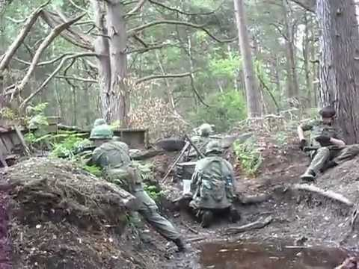

After searching due west of the Plei Me camp and not finding the elusive NVA forces, Maj. Gen Kinnard decided to shift his ops to the southwest - right into the Chu Pong Masaif. He had replaced his 3d Brigade with the 1st Brigade and was hoping to find the battered remnants of the 2 NVA regiments, licking their wounds and withdrawing into Cambodia. In this initial phase, examination of Kinnard's thought process in relation to the tenets of Air land Battle (i.e. Initiate) show:

- Initiate. Kinnard intended to set the terms of the battle, He was on the offensive and felt he could destroy the enemy with his superb division. lf he could find the enemy forces, he had the mobility and firepower to fix and destroy them, He was taking great risk and knew that the unit which made initial contact would be seriously outnumbered, but felt he could reinforce with fire almost immediately and then pile on troops before the enemy could react.

- Agility. The helicopter gave Kinnard the ability to act faster than the enemy. He could shift forces and combat power at almost mind-boggling speed. He could put both field artillery and aerial rocket artillery with great accuracy anywhere on almost of moment's notice. He could reinforce with troops faster than anyone ever experienced in the history of modern warfare. He had the communication capability and the troops trained in calls for fire. He could quickly concentrate on this weak and battered enemy and exploit his vulnerabilities. Cavalry tactics were such that they considered "friction'! the accumulation of chance errors, unexpected difficulties and the confusion of battle. Kinnard, by nature, disposition and training, knew that he had to continuously "read the battlefield," decide quickly and act without hesitation.

- Depth. Here again the helicopter and the cavalry's training in its use naturally extended ops in space, time and resources. The helicopter gave him extended range of vision for reconnaissance, allowed him to provide accurate aerial rocket artillery, adjust fire from the air, reposition his field artillery, re-supply his troops and reinforce with maneuver forces almost anywhere on the battlefield. His plan called for fixing the enemy and forcing of commitment, as well as interdicting uncommitted forces en-route to Cambodia. His rear areas were relatively safe, but he still provided an infantry battalion to secure his artillery and his forward command post. He had airstrips built so that he could be re-supplied from Saigon by the Air Force to his base at An Khe, and he also maintained sufficient helicopter lift assigned to move those supplies to the frontline troops. He was mentally prepared for bold and decisive action, and he had personally trained his handpicked brigade and battalion commanders with these same qualities.

- Synchronization. Two years of training together with all the modern technology had taught the cavalry how to arrange activities in time, space and purpose. Kinnard had the forces and combat power to produce maximum results at the decisive point. Synchronization for the cavalry did not depend on explicit coordination. Their training and communications capability were such that synchronization could take place during heavy conflict. Additionally, the commander's intent was clear - find the NVA regiments and destroy them. Clearly, the concept itself of searching with a battalion - piling on of brigade and supporting at the decisive time and place with the entire division, field force and Army fire support was an economy-of-force type operation.

It can be argued that in planning, each opposing commander was well within the umbrella of the tenets of Air land Battle. There was no apparent violation or misuse of initiative, agility, depth and synchronization. However, as the battle developed, some things become very evident. Man did not expect to fight the battle in his own sanctuary - nor did he expect to fight an American division. Additionally, he knew nothing of how the of Americans would fight. On Kinnard's part, he expected to be facing two beaten-up NVA regiments conducting a withdrawal. He did not expect to face more than 4,200 frontline troops, supported by mortars and anti-aircraft batteries, well supplied and not withdrawing but moving to attack.

It is at this stage that the "fog of war" reigns supreme. Here the commander with the best agility gains the initiative. It is the commander who can fight his fight - that is, setting the terms of battle and not allowing the enemy to recover - who will be the winner. Both Man and Kinnard exercised great mental agility as they attempted to gain the initiative. As the battle unfolded, the unexpected took over.

First, one battalion-size unit of the division, 1st Squadron, 7th Cavalry (17) airlifted in landing zone (LZ) X-Ray and made almost immediate contact with advance elements of the NVA force moving on Plei Me. Lt Col Harold G. Moore (the squadron commander) initially thought this was of stay-behind force of about one battalion, covering the enemy withdrawal.

Man immediately saw an opportunity to gain an immense victory by quickly annihilating an American unit that he significantly outnumbered, with the additional possibility of defeating in detail any relieving forces that would have to arrive piecemeal. In this he exercised great agility and took the initiative by accepting risk, the risk due to the fact that his entire force, especially his front-level mortar and anti-aircraft units, were not in of position to support the attack on X-Ray.

The brigade commander, Col Thomas Brown, and Kinnard quickly sensed that this was much more than a battered stay-behind force and recognized that the enemy intent was not to delay but to annihilate the 1-7th Cavalry. All available firepower was quickly reoriented to X-Ray and available forces began moving air and ground assets to support that fight. The ability of this small force to hold, and the tremendous and immediate firepower brought to beat was of shock to Man.

The agility of Kinnard's thought process and the agility of the cavalry organization itself quickly gave him the initiative. He reinforced 1-7 Cavalry with 2-7 Cavalry and elements of 1-5 Cavalry. The enemy had seen enough, and began relocating. Kinnard ordered 2-7 Cavalry to pursue. The pursuing unit fought another battle that took place at LZ Albany as Man was attempting to cover his withdrawal. The fight at LZ Albany was bloody, as the United States suffered 151 dead and 121 wounded, while the enemy lost about 450 killed. Kinnard then ordered the 2d Brigade to relieve the 3d Brigade and to continue to pursue. Over the next few days the 3d Brigade mopped up of few battered remnants of the 32d, 33d and 66th regiments as they were withdrawing into Cambodia Although Kinnard wished to continue the pursuit, he was ordered to hold. By 11-24 -65, the battles of the Ia Drang were over. The 1st Cavalry killed as many as 3,000 NVA regulars, with an unknown number of wounded, and, in fact, decimated the NVA force.

Clearly, Kinnard used the agility of the cavalry and his own ability to synchronize both combat power and logistic support (550 tons of supply of day and 50,000 gallons of aviation fuel) to seize and maintain the initiative on the battlefield. Additionally, he never had to commit more than 1 brigade at a time, thus exercising wisely the economy of his force. The agility of his forces and his ability to synchronize combat power allowed his units to fight outnumbered at least 7-to-1 overall and much greater at both X-Ray and Albany and win.

Green, untested American soldiers fought outnumbered against what Bernard Fall called "the best light infantry in the world," and won. The mental agility of Kinnard, the ability to synchronize combat power, and the agility in organization of the cavalry gave him the initiative, allowed him to fight his battle on his terms and win. He searched and he destroyed - and that was his mission. The training, discipline and leadership of both the 1st Cavalry Division under Kinnard and NVA forces under Man had been outstanding. But in the final analysis, organization and air mobility gave Kinnard the agility necessary to wrest the initiative from Man. And it was the initiative that ultimately made the difference.

What then did we learn from this first battle in Vietnam -- first and foremost a commander must be capable of gaining and maintaining the initiative, for without it he cannot win. Also, to gain the initiative, the commander must have both the mental and organizational agility to gain an advantage in relative combat power in depth, (time, space and resources), at the decisive point. In the battle of the Ia Drang, it was the great agility provided by the 1st Cavalry's organization that gave them the edge Kinnard needed.

It is also evident from of study of this battle that the tenets of Air land Battle doctrine are clearly interdependent, with gaining and maintaining the initiative being the most important tenet. An edge or advantage in one or all of the other tenets may give you that initiative as it did with the 1st Cavalry's agility and ability to synchronize its actions. General Man had the ability to synchronize his combat power and he had great depth in time, space and resources. He was willing to take risks and had great mental agility. The physical agility advantage, however, went to the cavalry and that was enough to gain the initiative.

We also learned that technology can provide just the edge in agility that is needed. However, technology is not enough. Commanders at ever level must be confident and trained to know how and when to apply that technology. If Maj. Gen. Kinnard had not been absolutely confident in his ability to rapidly reinforce with both firepower and troops, his actions would have been closer to stupidity than acceptable risk. Such was the case with General Man, who was ignorant of the capabilities of the American forces. His willingness to take risks without knowing those capabilities was, in fact, foolish and cost him three 1st-rate regiments.

While initiative, agility, depth and synchronization characterize successful ops, there are other key operations requirements. FM 100-5 calls them "Air Land Battle Imperatives." The imperative that seriously affected General Man is stated in the manual as "Concentrate combat power against enemy vulnerabilities." It explains, "to know what his vulnerabilities are, the commanders must study the enemy, know and take into account his strengths, find his inherent vulnerabilities, and know how to create vulnerabilities which can be exploited to decisive effect." This was Man's great failure and can be considered the cause of his defeat.

Note: Go to https://youtu.be/25x53ibwp7A and https://youtu.be/f9nWadSVw_o for a 27 and 14 minute videos on this battle

[Source: Military Review https://hadit.com/battle-ia-drang-valley-idv | LTC Kenneth R Pierce | January 1989 ++]

