HMS Hood Sinking

How Hitler's Most Powerful Battleship Sunk the Pride of the Royal Navy

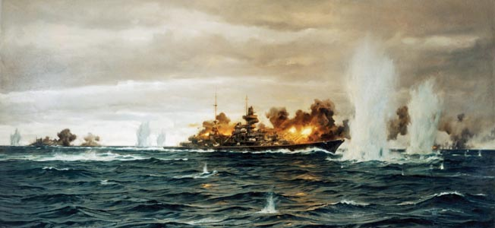

To this day, the cause of the sinking of the HMS Hood during the hunt for the Bismarck is still disputed.

The British Admiralty Board of Enquiry into the loss of the battlecruiser HMS Hood, presided over by Vice Admiral Sir Geoffrey Blake, concluded, “The sinking of Hood was due to a hit from Bismarck’s 15-inch shell in or adjacent to Hood’s 4-inch or 15-inch magazines, causing them to explode and wreck the after part of the ship.” Director of Naval Construction Sir Stanley Goodall, however, found this conclusion unsatisfactory and in his report pointed out the explosion was observed near the mainmast 65 feet further forward from the aft magazines. A second board of enquiry was convened under Rear Admiral H.T.C Walker. Even given eyewitness accounts that described fires on deck, that board still found a hit by Bismarck being the likely cause, although finishing with, “The probability is that the 4-inch magazines exploded first.”

Taking on the Feared Bismarck

In May 1941, Admiral Sir John C. Tovey, commander of the British Home Fleet at Scapa Flow in Scotland’s Orkney Islands, was ordered to attack the German battleship Bismarck and heavy cruiser Prinz Eugen that had just been spotted in the Denmark Strait. Tovey’s fleet consisted of two new battleships, King George V and Prince of Wales, the battlecruisers Hood and Repulse, and the aircraft carrier Victorious, plus many additional cruisers and destroyers. Also hurrying north to join him was the older battleship Rodney, mounting nine 16-inch guns, the largest caliber in the fleet.

Of all the German surface warships, the British feared Bismarck the most. Her size, speed, and firepower made her a definite threat to Allied shipping in the Atlantic, and it was imperative that she be neutralized.

On May 21, 1941, Hood and Prince of Wales left Scapa Flow with six destroyers under the command of Admiral Lancelot Holland flying his flag in Hood, their mission to provide heavy support to the cruisers Suffolk and Norfolk covering the Denmark Strait between Greenland and Iceland––one of the likely routes the German naval squadron would take to reach the North Atlantic. The rest of the fleet was gathering to cover the area between Iceland and the Orkney Islands.

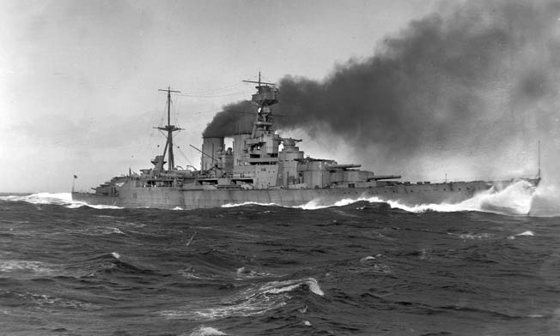
The battlecruiser HMS Hood, launched in 1918.

Early on the evening May 23, Suffolk made contact with the enemy ships, quickly turning away toward the coast of Iceland and into a fog bank. Suffolk immediately transmitted a sighting report to the Admiralty and then came around astern of the German ships to shadow them on radar. Norfolk came up as well, a little too boldly, for Bismarck opened fire on her; like Suffolk, she raced for the fog bank. The blast from Bismarck’s 15-inch guns disabled her own forward radar, and overall German commander Admiral Gunther Lütjens ordered Prinz Eugen to take the lead.

The Germans had picked up the sighting report from Suffolk and advised their own high command. Lütjens was shocked their presence had been discovered so easily and had little intelligence on what his two warships might face.

The Dwindling British Advantage

As the two forces moved toward each other, Holland had a marked two-to-one superiority in firepower. However, this was offset by the age of the Hood (commissioned in 1920) and the newness (commissioned in January 1941) and lack of combat readiness of Prince of Wales, which was still having trouble with her main armament.

Holland soon realized he was in a favorable position to bring the enemy to action that evening, sailing northwesterly toward the Denmark Strait with the enemy on a southwesterly course. He hoped to catch the Germans just before sunset at around 2 am at 65 degrees north latitude. He also hoped to cross the German squadron’s “T,” which would give him a great advantage. “Crossing the T” is a tactic in naval warfare in which a line of warships crosses in front of a line of enemy ships, allowing them to bring all their guns to bear while receiving fire from only the forward guns of the enemy.

During the evening of May 23, the forces converged. Suffolk continued to shadow and update the Admiralty, Holland on Hood, and Tovey on King George V. Around midnight, Suffolk lost contact because her radar was blinded by a snowstorm the German ships had entered. Holland waited an hour but, hearing no news, turned more northerly in case the enemy turned south. He could not afford a German breakout into the North Atlantic. At 2 am, still with no news, he turned southwesterly hoping to cut off the enemy before total darkness.

About an hour later, Suffolk regained radar contact and discovered the German ships were still on their original course. Holland must have cursed his luck, for his maneuvering had lost time and space, and the opportunity to cross the T was gone; this would prove critical in the coming battle.

Failing to Concentrate Fire on the Bismarck

Not wanting a night engagement, Holland brought his ships onto a course to intercept the German squadron at first light, keeping up a good speed but in the heavy seas dropping the escorting destroyers astern. By dawn, the destroyers were an hour behind. Lookouts scanned the horizon for a glimpse of their quarry. At 5:37 am the two ships were spotted to the northwest, 30,000 yards (17 miles) away. The heavy guns could fire that far but the chance of a hit was remote; they needed to reduce the range to 25,000 yards or less––and quickly.

Prinz Eugen had already picked up the sound of ships with her underwater detection gear at some 20 miles to the southeast. At about the same time as the British lookouts spotted them, the Germans spotted smoke on the horizon. Lütjens believed that these were likely more cruisers, and he was under orders to avoid contact with British warships. He turned to starboard and headed almost due west, confident that he could outrun them.

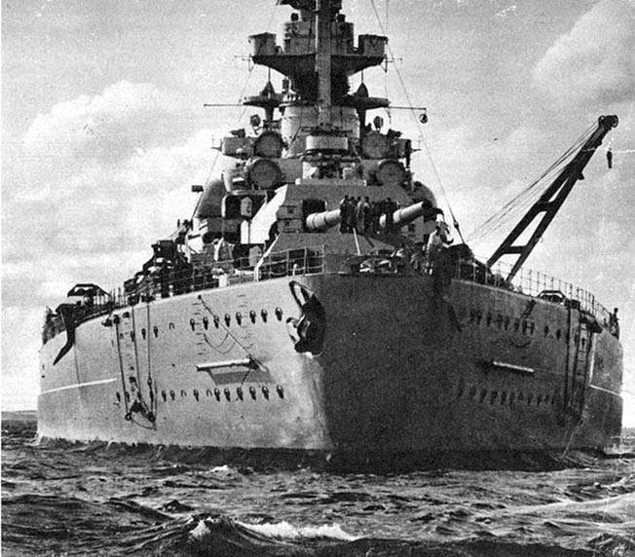
Bismarck, pride of the German Navy, shown during sea trials, March 1941.

Holland was soon aware the enemy had turned away, but he had to maintain his intercept course. Turning toward them would merely put his ships behind the Germans and make it a chase. By 5:50 am, the range was down to 26,000 yards, and Holland would soon give the order to open fire. He was fully aware of Hood’s vulnerability to plunging fire at long range and wanted to pass through the critical zone as fast as possible. Therefore, he compromised by turning 20 degrees to starboard on a new course of 300 degrees toward the enemy. This would close with the enemy faster but make it impossible for the rear turrets of the British ships to bear on the Germans.

At 5:52 am, Holland designated the lead ship as the target and gave the order to open fire. This caused Captain John Leach of Prince of Wales a few anxious moments, for he was convinced that the rear ship was Bismarck, posing the greater threat. He ignored the orders from Holland and concentrated on Bismarck. In seconds, huge columns of water erupted around Prinz Eugen, followed seconds later around Bismarck. Lütjens now had no doubt about what he faced. However, the British angle of approach still made identification difficult. Marking the fall of shots, the British ships fired another salvo still firing at different targets. Leach had not informed Holland of his opinion and later had not been informed by his own gunners that Prince of Wales was firing at the second ship.

The Hood is Struck

The range was down to 24,000 yards when Lütjens ordered his ships to turn 65 degrees to port toward the British on a new course of 200 degrees and directed his ships to open fire as soon as they had turned. Lütjens was now on course to cross the British T and would be able to employ all his ships’ heavy guns. Prinz Eugen opened fire first at 5:53 am, concentrating on the lead British ship, Hood, with her fast-firing 8-inch guns at four salvos per minute; she was firing high-explosive, not armor-piercing shells. After a few ranging salvos, Prinz Eugen hit Hood, her shells starting a large fire amidships among the ammunition lockers of the 4-inch antiaircraft guns, as well as ammunition for the unrifled projectile launchers used for defense against aircraft. Attempts to put out the fire were frustrated by the exploding ammunition.

Both British ships were still firing but at different targets. As yet, Bismarck had not opened fire. By now the range was down to 22,000 yards. After turning, Bismarck opened fire on Hood at 5:55 am with all eight 15-inch guns. Her first salvo fell close to Hood. At last Hood’s gunners realized they had been firing at the wrong ship. About this time, Holland ordered another 20 degree turn to port. This turn still would not allow the British ships to use their rear turrets.

At 5:59 am, Holland ordered another 20-degree turn to port, which would finally allow his ships to bring their full armament to bear. The range was now down to 18,000 yards. Bismarck fired three salvos in rapid succession about 30 seconds apart. The first, the fourth in total, again straddled Hood, but the fifth hit with devastating effect at about 6 am. For the sailors aboard Hood, their worst nightmares were about to come true.

Explosion on the Hood

Ted Briggs had joined Hood as a signal boy on March 7, 1938, at just 15 years of age. Three years later he was an ordinary signalman on Hood’s compass platform, manning the voice pipe to the flag deck. During the battle, Hood’s X Turret fired for the first time, but Y Turret was silent. Seconds later, Briggs saw a blinding flash sweep around the outside of the compass platform. However, he said there “was not a terrific explosion at all regards noise.” He felt the ship “jar” and begin listing to port. The “jar” was the ship breaking in two. The list got worse, and the men began leaving his area. By the time Briggs climbed down the ladder to the admiral’s bridge, the icy sea was already around his legs.

Eighteen-year-old Midshipman William Dundas had the duty of watching Prince of Wales to make sure she was keeping station; he was not far from Ted Briggs on the compass platform. He remembered bodies falling past his position from the higher spotting positions––the result, he felt, of Bismarck’s shells hitting without exploding. He recalled a mass of brown smoke just before the list to port began. Dundas escaped by kicking out a window on the starboard side of the compass platform. Even so, he was dragged under the water by the sinking ship but miraculously regained the surface.

Twenty-year-old Able Seaman Robert Tilburn was stationed at Hood’s aft-port 4-inch antiaircraft gun and witnessed the fire started by Prinz Eugen’s shells. The heat of the blaze made fire fighting impossible as the flames were being fanned by Hood’s 28-knot speed. Then he said, “The ship shook like mad” and began listing to port. Tilburn got onto the forecastle but was washed over the side by a great wave. At the second board of enquiry, Tilburn told the admirals, “The Bismarck hit us. There was no doubt about that. She hit us at least three times before the final blow.”

Briggs, Dundas, and Tilburn were the only survivors from Hood; her 1,415 other crewmen were lost. But there were other witnesses, such as Lieutenant Esmond Knight. Aboard Prince of Walesobserving Hood, he remembered thinking, “It would be a most tremendous explosion, but I don’t remember hearing an explosion at all.” Chief Petty Officer French, also on Prince of Wales, said that the middle of the Hood’s boat deck appeared to rise before the mainmast.

Leading Sick-Berth Attendant Sam Wood, also on Prince of Wales, observed, “I was watching the orange flashes coming from Bismarck, so naturally I was on the starboard side. The leading seaman who was with me said, ‘Christ, look how close the firing is getting to Hood.’ As I looked out, suddenly Hood exploded. She was one pall of black smoke. Then she disappeared into a big orange flash and a huge pall of smoke which blacked us out…. The bows pointed out of the smoke, just the bows, tilted up, and then this whole apparition slid out of sight, all in slow motion, just slid away.” Within three minutes Hood was gone.

What Destroyed the Hood?

So what did happen to Hood? Were the boards of enquiry right that a 15-inch shell from Bismarck had hit close to her 4-inch and/or 15-inch magazines, causing an explosion that wrecked the after part of the ship? What evidence we have would seem to shed some doubt on this. First, Hood was about 17,000 yards from Bismarck by 6 am. By that time, the heavy shells from both sides were travelling on a fairly low trajectory. As the range decreased, the guns would have been progressively depressed. Therefore, any hit would have been more likely to strike the belt. Hood’s belt armor was 12-inches thick and superior to any ship in the fleet; it was also inclined at 12 degrees.

It is still possible a shell could have hit the deck with its thin armor of three inches, but not with the plunging effect Holland had feared at long range. The shell likely fell at a rather oblique angle, which would make penetration of four decks to the main magazine under X Turret unlikely. Also, it was witnessed aboard Hood and Prince of Wales that Bismarck’s 15-inch shells were likely defective, that most failed to explode. Could there have been some sort of cordite flash explosion similar to those that destroyed three British battle cruisers during the battle of Jutland in May 1916?

This again seems highly unlikely as Hood’s shell-handling rooms were situated well below the X and Y Turrets’ magazine and the engine room thanks to lessons learned from that tragic Jutland episode. Also at Jutland, all three battlecruisers were destroyed by massive explosions, and there was none audible on Hood. One question about the magazine theory is why Y Turret did not fire like X had. Was something already happening there?

Then there is the fire started by Prinz Eugen’s 8-inch shells. Captain Leach of Prince of Wales described the fire as “a vast blowlamp.” The fire consumed much combustible material on the deck and upper superstructure, but the two- and three-inch deck armor and forecastle armor prevented this fire from penetrating below. The ventilation systems were fitted with gas-tight flaps and, at action stations, all should have been closed. Thus, it is fairly certain that the deck fires could not have resulted in Hood breaking in two or could even have contributed to this significantly.

The second board of enquiry did look at the possibility of Hood’s own above-deck torpedoes causing her to sink. Sir Stanley Goodall, who had supervised Hood’s design, believed an enemy shell could have detonated the torpedo warheads in their tubes. Four 21-inch MK IV torpedoes were kept in tubes, two on either side of the mainmast, and four reloads were nearby in a three-inch armored box. These torpedoes were certainly capable of breaking Hood’s back and could have been set off either by a direct hit from an enemy shell or by an intense fire. the TNT in the warheads would ignite at around 250 degrees Fahrenheit and explode at around 280 degrees. Again, however, there was no explosion. It is worth noting that similar torpedo tubes on the battlecruisers Repulse and Renown were later removed.

Was there some sort of underwater penetration? This seems even more unlikely. Hood was outside torpedo range of the German ships. One of Bismarck’s 15-inch shells could have penetrated the side and exploded in or near Hood’s shell-handling rooms––again unlikely without evidence of a massive explosion.

A Lucky Shot

The final theory or possibility is that Prinz Eugen’s 8-inch guns, firing at over half their maximum range, would have been falling on the target at a much steeper trajectory than Bismarck’s 15-inch guns and that one of her high-explosive 8-inch shells might have gone down Hood’s after funnel. If this did happen, it would have been just before Lütjens ordered Prinz Eugen to shift her fire to Prince of Wales, about the time Hood was engulfed.

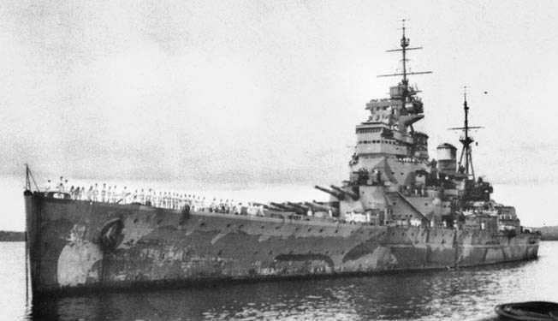
HMS Prince of Wales was completed a month before her engagement with Bismarck when the ship was severely damaged. On December 10, 1941 she was sunk by the Japanese along with HMS Replulse near Singapore on December 9, 1941.

The wire cage that covered the top of the funnel would not stop a shell and would be unlikely to explode it. The next obstacle on a shell’s journey would have been a steel grating positioned in vents at the level of the lower deck to protect the boiler room. If an 8-inch shell exploded here, it would have detonated in the boiler room. A high-explosive shell bursting in one of the boiler rooms or nearby might have resulted in an enormous buildup of pressure, resulting in an explosion inside the ship. The line of least resistance to this would have been up through Hood’s thin decks, not through the heavily armored sides or bottom.

Was this the result, a muffled explosion within the ship only heard below decks, the flash seen above decks near the mainmast with the propellers still turning driving the rear into the severely weakened midsection and breaking Hood in two parts? Could it have been a fatal combination of two of these theories?

In July 2001, the wreck of the Hood was found 9,334 feet below the surface of the Denmark Straight. She lies in three sections with the bow on its side, the mid section upside down, and the stern speared into the seabed. In 2013, the wreck was more fully explored with a remote-control vehicle. The exploration appears to confirm a massive explosion had taken place in the magazine feeding Y Turret and breaking the back of the ship. However, it remains a mystery, given the low trajectory of any shell, how one could have passed through four decks and the magazine armor. It must have been a lucky shot, indeed.

Prince of Wales Escapes

After the loss of the Hood, the battle continued. Prince of Wales was about 1,000 yards astern of Hood. Seeing the flagship explode, Captain Leach ordered a hard turn to starboard to avoid the wreckage. Hood was engulfed in smoke, but the stern was still above the water. The forward section still had some momentum but was listing to port and sinking rapidly. After clearing the wreckage, Leach swung Prince of Wales back onto 260 degrees, bringing his full broadside to bear.

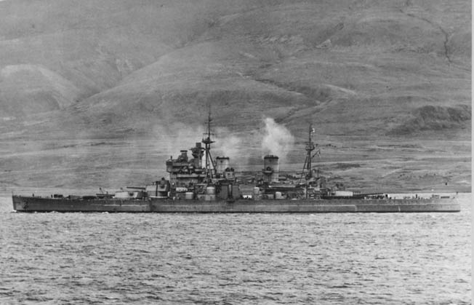
Photo taken from Prinz Eugen shows Bismarck firing on HMS Prince of Wales. The British ship was hit and badly damaged but did not sink.

The turn of Prince of Wales disrupted the gunners on Bismarck and Prinz Eugen, but they soon found the range again. With the range down to 15,000 yards, the fire from both sides was finding its mark. A 15-inch shell from Bismarck hit the bridge of Prince of Wales. Although it did not explode, it killed several key personnel, and for a short period disrupted command of the ship. Direction was transferred to the aft position. She was also hit by an 8-inch shell from Prinz Eugen, knocking out fire control of several 5.25-inch guns, and two more hits caused minor flooding. At 6:03 am, Bismarck passed the port beam of Prinz Eugen, causing that ship to temporarily cease fire. The heavy cruiser had turned away because of suspected torpedoes.

Leach did not close the range. Prince of Wales had managed to hit Bismarck three times, although no explosions had been observed. Bismarck struck back, hitting the starboard crane of Prince of Wales, causing much splinter damage. Another shell hit amidships below the rear funnel under the waterline but failed to explode. It did cause some flooding and required the ship to counter flood to maintain trim. Leach felt his ship was taking heavy damage––it had been hit four times by Bismarck and three times by Prinz Eugen. His own ship’s main armament was still not working properly, and his crew lacked the experience to adjust for this. Believing his ship might suffer serious damage, Leach ordered Prince of Wales to withdraw behind a smoke screen at 6:05. Also, Bismarck had completed passing Prinz Eugen so that ship’s guns would soon be back in action. Whether this influenced Leach is unknown.

Admiral Lütjens was surprised to see Prince of Wales turn away, but he dismissed calls from some of his men to pursue the British ship. It was doubtful they would be able to catch her. Also, Bismarck herself had been hit. Two shells had caused minor damage. However, one 14-inch shell had struck below the waterline causing some flooding and reduction in speed. Worse, some fuel tanks had been ruptured causing the loss of several hundred tons of precious fuel oil. Lütjens soon realized he could not continue with the mission to attack British convoys due to the loss of fuel. Prinz Eugen was therefore detached to proceed with raiding while Bismarck turned back. The battleship headed for the nearest port with a drydock big enough to take Bismarck, at St. Nazaire, France.

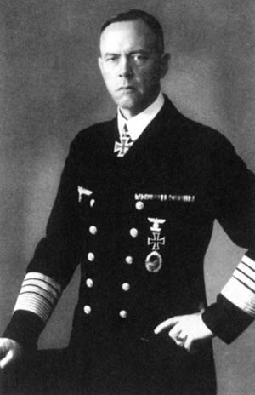
Bismarck’s captain, Admiral Günther Lütjens, went down with the ship after it was attacked and sunk on May 27, 1941

On May 26, a British aircraft spotted the battleship and radioed her position to other warships in the area. A force of 15 Fairey Swordfish torpedo planes from the carrier Ark Royal converged on Lütjens’ ship, and one torpedo damaged Bismarck’s rudder so badly that all the giant ship could do was sail helplessly in a circle. Like a pack of lions, the chasing British battleships Rodney and King George V caught and engaged Bismarck at a range of 16,000 yards. The German gunners’ return fire was ineffective, and the helpless Bismarck was torn apart. At 10:40 am on May 27, 1941, the German battleship sank some 300 nautical miles west of Ushant, France. Only 110 of her crew of 2,222 survived the sinking. Admiral Lütjens went down with the ship.
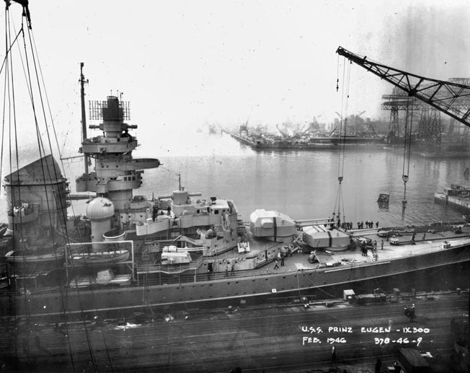
Prinz Eugen accompanied Bismarck during their breakout into the North Atlantic. After surviving the war, Prinz Eugen was turned over to the U.S. Navy and sunk in 1946 during atomic-bomb testing at Bikini Atoll

[Source: Warfare History Network | Mark Simmons | April 18, 2017 ++]

