Military History Anniversaries 16 thru 31 MAR

Events in History over the next 15 day period that had U.S. military involvement or
impacted in some way on U.S military operations or American interests

- Mar 16 1802 – The United States Military Academy–the first military school in the United States–is founded by Congress for the purpose of educating and training young men in the theory and practice of military science. Located at West Point, New York, the U.S. Military Academy is often simply known as West Point.

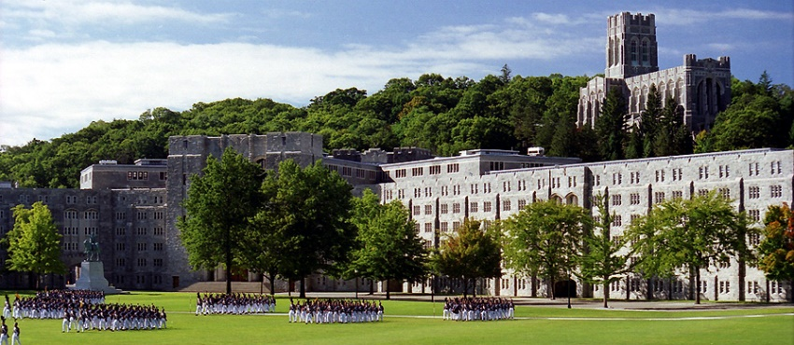

- Mar 16 1865 – Civil War: Battle of Averasboro - Union General William T. Sherman encounters its most significant resistance as it tears through the Carolinas on its way to join General Ulysses Grant’s army at Petersburg, Virginia. Confederate General William Hardee tried to block one wing of Sherman’s force but the motley Rebel force was swept aside at in this North Carolina battle Casualties and Losses: US 95 killed, 530 wounded, 50 missing | CSA lost about 865 total.
- Mar 16 1916 – WW1: Admiral Alfred von Tirpitz, the man largely responsible for the buildup of the German navy in the years before World War I and the aggressive naval strategy pursued by Germany during the first two years of the war, tenders his resignation to Kaiser Wilhelm II, who—somewhat to Tirpitz’s surprise—accepts it.

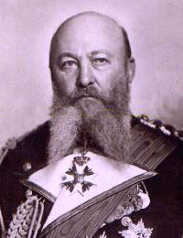

- Mar 16 1935 – Adolf Hitler orders Germany to rearm herself in violation of the Versailles Treaty.
- Mar 16 1942 – WW2: The first V–2 rocket test launch. It explodes at liftoff.
- Mar 16 1945 – WW2: The Battle of Iwo Jima ends but small pockets of Japanese resistance persist. Casualties and losses: US 26,038 - JP 22,060
- Mar 16 1968 – Vietnam: My Lai – In the most publicized war atrocity committed by U.S. troops in Vietnam, a platoon slaughters between 200 and 500 unarmed men, women, and children at My Lai 4 village, a cluster of hamlets in the coastal lowlands of the northernmost region of South

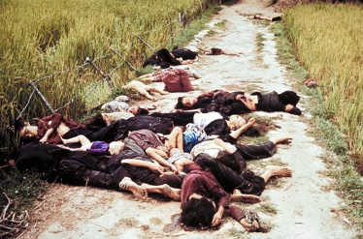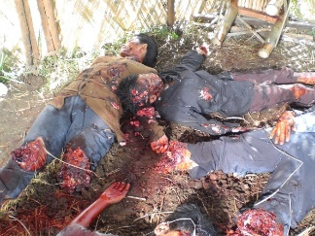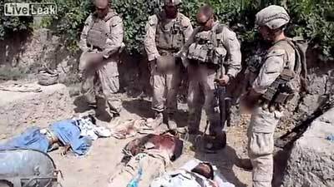

- Mar 16 1988 – Cold War: Honduras - President Ronald Reagan orders over 3,000 U.S. troops to the country, claiming that Nicaraguan soldiers had crossed its borders. As with so many of the other actions taken against Nicaragua during the Reagan years, the result was only more confusion and criticism.
- Mar 16 1975 – Vietnam: The withdrawal from Pleiku and Kontum begins, as thousands of civilians join the soldiers streaming down Route 7B toward the sea.
- Mar 17 1776 – American Revolution: British forces are forced to evacuate Boston following General George Washington’s successful placement of fortifications and cannons on Dorchester Heights, which overlooks the city from the south.
- Mar 17 1780 – American Revolution: George Washington grants the Continental Army a holiday "as an act of solidarity with the Irish in their fight for independence".
- Mar 17 1863 – Civil War: Battle of Kelly’s Ford - Union cavalry attack Confederate cavalry at Kelly’s Ford, Virginia. Although the Yankees were pushed back and failed to take any ground, the engagement proved that the Federal troopers could hold their own against their Rebel counterparts. Casualties and losses: US 78 killed, wounded, and captured - CSA lost a total of 133 men.
- Mar 17 1917 – WW1: In the midst of Allied plans for a major spring offensive on the Western Front, the French government suffers a series of crises in its leadership, including the forced resignation of Prime Minister Aristide Briand. Horrified by the brutal events at Verdun and the Somme in 1916, the French Chamber of Deputies had already met in secret to condemn the leadership of France’s senior military leader, Joseph Joffre, and engineer his dismissal.
- Mar 17 1940 – WW2: Dr. Fritz Todt, an engineer and master road builder, is appointed Minister for Weapons and Munitions, ushering in a new era in the efficient use of German industry and forced labor.
- Mar 17 1942 – WW2: Holocaust - The first Jews from the Lviv Ghetto (western Ukraine) are gassed at the Belzec death camp (eastern Poland).
- Mar 17 1945 – WW2: The Ludendorff Bridge in Remagen, Germany collapses, ten days after its capture.

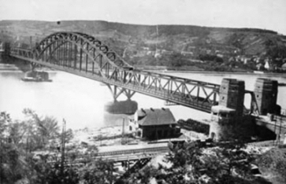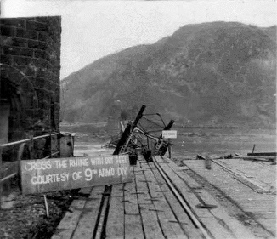

- Mar 17 1947 – First flight of the B-45 Tornado strategic bomber.
- Mar 17 1960 – U.S. President Dwight D. Eisenhower signs the National Security Council directive on the anti-Cuban covert action program that will ultimately lead to the Bay of Pigs Invasion.
- Mar 17 1964 – Vietnam: President Lyndon B. Johnson presides over a session of the National Security Council during which Secretary of Defense McNamara and Gen. Maxwell Taylor present a full review of the situation in Vietnam. During the meeting, various secret decisions were made.
- Mar 17 1966 – Off the coast of Spain in the Mediterranean, the DSV Alvin submarine finds a missing American hydrogen bomb.
- Mar 17 1968 – Cold War: As a result of nerve gas testing in Skull Valley, Utah, US, over 6,000 sheep are found dead.
- Mar 17 1970 – My Lai Massacre: The United States Army charges 14 officers with suppressing information related to the incident.
- Mar 17 1973 – Vietnam: First POWs are released from the "Hanoi Hilton" in Hanoi, North Vietnam.
- Mar 17 1990 – Cold War: The former Soviet Socialist Republic of Lithuania steadfastly rejects a demand from the Soviet Union that it renounce its declaration of independence. The situation in Lithuania quickly became a sore spot in U.S.-Soviet relations.
- Mar 18 1766 – American Revolution: After four months of widespread protest in America, the British Parliament repeals the Stamp Act, a taxation measure enacted to raise revenues for a standing British army in America.
- Mar 18 1865 – Civil War: The Congress of the Confederate States adjourns for the last time.
- Mar 18 1915 – WWI: Battle of Gallipoli - British and French forces launch an ill-fated naval attack on Turkish forces in the Dardanelles, the narrow, strategically vital strait in northwestern Turkey separating Europe from Asia. Three battleships are sunk during a failed British and French naval attack on the Dardanelles.

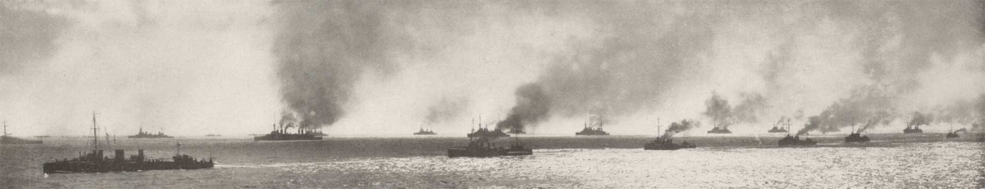

- Mar 18 1940 – WW2: Axis Powers - Adolf Hitler and Benito Mussolini meet at the Brenner Pass in the Alps and agree to form an alliance against France and the United Kingdom.
- Mar 18 1942 – WW2: The War Relocation Authority is created to “Take all people of Japanese descent into custody, surround them with troops, prevent them from buying land, and return them to their former homes at the close of the war.”
- Mar 18 1945 – WW2: 1,250 American bombers attack Berlin.
- Mar 18 1950 – Cold War: In a surprise raid on the communist People’s Republic of China (PRC), military forces of the Nationalist Chinese government on Taiwan invade the mainland and capture the town of Sungmen. Because the United States supported the attack, it resulted in even deeper tensions and animosities between the U.S. and the PRC.
- Mar 18 1969 – Vietnam: Operation Breakfast - U.S. B-52 bombers are diverted from their targets in South Vietnam to attack suspected communist base camps and supply areas in Cambodia for the first time in the war.
- Mar 19 1863 – Civil War: The SS Georgiana, said to have been the most powerful Confederate cruiser, is destroyed on her maiden voyage with a cargo of munitions, medicines and merchandise then valued at over $1,000,000.
- Mar 19 1865 – Civil War: Battle of Bentonville NC - Confederate General Joseph Johnston makes a desperate attempt to stop Union General William T. Sherman’s drive through the Carolinas in the War’s last days; however, Johnston’s motley force could not stop the advance of Sherman’s mighty army. By the end of the battle two days later, Confederate forces had retreated. Casualties and losses: US 1,527 - CSA 2,606
- Mar 19 1916 – WW1: Mexico - The First Aero Squadron, organized in 1914 after the outbreak of World War I, flies a support mission for the 7,000 U.S. troops who, six days earlier, had invaded Mexico on President Woodrow Wilson’s orders to capture Mexican revolutionary Francisco Pancho Villa dead or alive.
- Mar 19 1941 – WW2: The 99th Pursuit Squadron also known as the Tuskegee Airmen, the first all–black unit of the Army Air Corp, is activated.
- Mar 19 1944 – WW2: Nazi forces occupy Hungary.
- Mar 19 1945 – WW2: Adolf Hitler issues his "Nero Decree" ordering all industries, military installations, shops, transportation facilities and communications facilities in Germany to be destroyed.
- Mar 19 1945 – WW2: The commander of the German Home Army, Gen. Friedrich Fromm, is shot by a firing squad for his part in the July plot to assassinate the Fuhrer. The fact that Fromm’s participation was half-hearted did not save him.

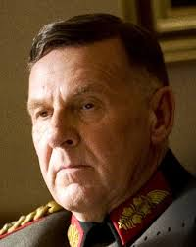

- Mar 19 1945 – WW2: Off the coast of Japan, a dive bomber hits the aircraft carrier USS Franklin, killing 724 of her crew. Badly damaged, the ship is able to return to the U.S. under her own power.
- Mar 19 1945 – Cold War: In a precursor to the establishment of a separate, Soviet-dominated East Germany, the People’s Council of the Soviet Zone of Occupation approves a new constitution. This action, together with the U.S. policy of pursuing an independent pathway in regards to West Germany, contributed to the permanent division of Germany.
- Mar 19 1965 – The wreck of the SS Georgiana, valued at over $50,000,000 and said to have been the most powerful Confederate cruiser, is discovered by teenage diver and pioneer underwater archaeologist E. Lee Spence, exactly 102 years after its destruction.
- Mar 19 1966 – Vietnam: The South Korean Assembly votes to send 20,000 additional troops to Vietnam to join the 21,000 Republic of Korea (ROK) forces already serving in the war zone. The South Korean contingent was part of the Free World Military Forces, an effort by President Lyndon B. Johnson to enlist allies for the United States and South Vietnam.
- Mar 19 1970 – Vietnam: Cambodia - The National Assembly grants “full power” to Premier Lon Nol, declares a state of emergency, and suspends four articles of the constitution, permitting arbitrary arrest and banning public assembly. Lon Nol and First Deputy Premier Prince Sisowath Sirik Matak had conducted a bloodless coup against Prince Norodom Sihanouk the day before and proclaimed the establishment of the Khmer Republic.
- Mar 19 2002 – Afghanistan: Operation Anaconda ends (started on March 2) after killing 500 Taliban and al Qaeda fighters with 11 allied troop fatalities.
- Mar 19 2003 – Iraq: The United States, along with coalition forces primarily from the United Kingdom, initiates war on Iraq. Just after explosions began to rock Baghdad, U.S. President George W. Bush announced in a televised address, “At this hour, American and coalition forces are in the early stages of military operations to disarm Iraq, to free its people and to defend the world from grave danger.”

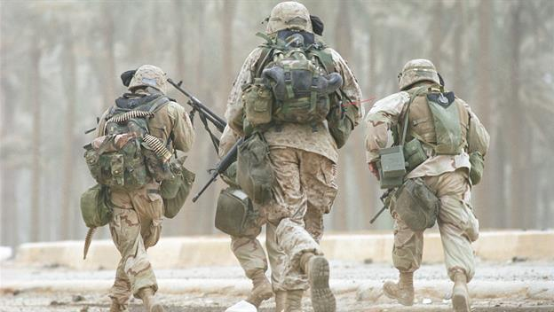

- Mar 20 1778 – American Revolution: Benjamin Franklin, Silas Deane and Arthur Lee present themselves to France’s King Louis XVI as official representatives of the United States. Louis XVI was skeptical of the fledgling republic, but his dislike of the British eventually overcame these concerns and France officially recognized the United States.
- Mar 20 1922 – WW1: Just two days after its navy suffered a demoralizing defeat against Turkish forces at the Dardanelles, the British government signs a secret agreement with Russia regarding the hypothetical post-World War I division of the former Ottoman Empire.
- Mar 20 1922 – The USS Langley (CV–1) is commissioned as the first United States Navy aircraft carrier.

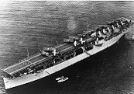

- Mar 20 1942 – WW2: Holocaust - In Rohatyn, western Ukraine, the German SS murder 3,000 Jews, including 600 children, annihilating 70% of Rohatyn's Jewish ghetto.
- Mar 20 1942 – WW2: General Douglas MacArthur, at Terowie, South Australia, makes his famous speech regarding the fall of the Philippines, in which he says: "I came out of Bataan and I shall return".
- Mar 20 1944 – WW2: Four thousand U.S. Marines made a landing on unoccupied Emirau Island in the Bismarck Archipelago to develop an airbase as part of Operation Cartwheel for the encirclement of the major Japanese base at Rabaul.
- Mar 20 1945 – WW2: USS Kete (SS–369) missing. Most likely sunk by a mine or a Japanese submarine (perhaps RO 41) east of Okinawa. 87 killed
- Mar 20 1945 – WW2: The 14th Army, under British Gen. William J. Slim, captures the Burmese city of Mandalay from the Japanese, bringing the Allies one step closer to liberating all of Burma.
- Mar 20 1952 – Post-WW2: The United States Senate ratifies a peace treaty with Japan.
- Mar 20 1953 – Cold War: The Soviet government announces that Nikita Khrushchev has been selected as one of five men named to the new office of Secretariat of the Communist Party. Khrushchev’s selection was a crucial first step in his rise to power in the Soviet Union—an advance that culminated in Khrushchev being named secretary of the Communist Party in September 1953, and premier in 1958.
- Mar 20 1954 – Vietnam: After a force of 60,000 Viet Minh with heavy artillery had surrounded 16,000 French troops, news of Dien Bien Phu’s impending fall reaches Washington.
- Mar 20 1968 – Vietnam: Retired U.S. Marine Corps Commandant Gen. David Shoup estimates that up to 800,000 men would be required just to defend South Vietnamese population centers. He further stated that the United States could only achieve military victory by invading the North, but argued that such an operation would not be worth the cost.

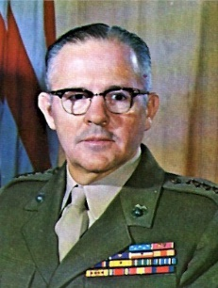
Gen. David Shoup

- Mar 20 1969 – Vietnam: U.S President Nixon proclaims he will end Vietnam War in 1970.
- Mar 20 2003 – Iraq: Invasion of Iraq by American and British led coalition (the UK, Australia and Poland) begins without United Nations support and in defiance of world opinion.
- Mar 21 1778 – American Revolution: Massacre at Hancock’s Bridge - Just three days after British Loyalists and Hessian mercenary forces assault the local New Jersey militia at Quinton’s Bridge, three miles from Salem, New Jersey, the same contingent surprises the colonial militia at Hancock’s Bridge, five miles from Salem. During the battle, the Loyalists not only kill several members of the Salem militia, but also two known Loyalists.
- Mar 21 1918 – WWI: The German Army opened the Spring Offensive with Operation Michael (First Battle of the Somme) attempting to break through the Allied lines and to seize ports on the English Channel.
- Mar 21 1943 – WW2: Wehrmacht officer Rudolf von Gersdorff plots to assassinate Adolf Hitler by using a suicide bomb at the Zeughaus Museum in Berlin, where Hitler was to attend the annual memorial dedication. Once at the exhibition hall, Gersdorff was informed that the Fuhrer was to inspect the exhibits for only eight minutes—not enough time for the 10 minute fuses to melt down. Von Gersdorff was able to defuse the bomb in time and avoid suspicion.

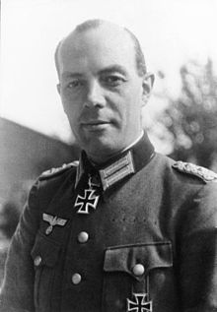
Rudolf von Gersdorff

- Mar 21 1945 – WW2: British troops liberate Mandalay, Burma.
- Mar 21 1945 – WW2: Operation Carthage: Royal Air Force planes bomb Gestapo headquarters in Copenhagen, Denmark. They also hit a school and 125 civilians are killed.
- Mar 21 1945 – WW2: Bulgaria and the Soviet Union successfully complete their defense of the north bank of the Drava River as the Battle of the Transdanubian Hills concludes. Casualties and losses: Unknown
- Mar 21 1945 – WW2: 1st Japanese flying bombs (ochas) attack Okinawa.

Yokosuka MXY7 Ohka

- Mar 21 1967 – Vietnam: The North Vietnamese press agency reports that an exchange of notes took place in February between President Lyndon B. Johnson and Ho Chi Minh. The agency said that Ho rejected a proposal made by Johnson for direct talks between the United States and North Vietnam on ending the war. The North Vietnamese demanded that the United States “stop definitely and unconditionally its bombing raids and all other acts of war against North Vietnam.” Nothing of any consequence came from Johnson’s initiative.
- Mar 21 1971 – Vietnam: Two U.S. platoons in Vietnam refuse their orders to advance
- Mar 21 1972 – Vietnam: In Cambodia, more than 100 civilians are killed and 280 wounded as communist artillery and rockets strike Phnom Penh and outlying areas in the heaviest attack since the beginning of the war in 1970. Following the shelling, a communist force of 500 troops attacked and entered Takh Mau, six miles southeast of Pnom Penh, killing at least 25 civilians.
- Mar 21 1980 – Cold War: President Jimmy Carter informs a group of U.S. athletes that, in response to the December 1979 Soviet incursion into Afghanistan, the United States will boycott the 1980 Olympics in Moscow. It marked the first and only time that the United States has boycotted the Olympics.
- Mar 22 1713 – The Tuscarora War comes to an end with the fall of Fort Neoheroka, effectively opening up the interior of North Carolina to European colonization.
- Mar 22 1765 – American Revolution: Stamp Act - In an effort to raise funds to pay off debts and defend the vast new American territories won from the French in the Seven Years’ War (1756-1763), the British government passes the Stamp Act. The legislation levied a direct tax on all materials printed for commercial and legal use in the colonies, from newspapers and pamphlets to playing cards and dice. This along with other British taxes raised the issue of taxation without representation

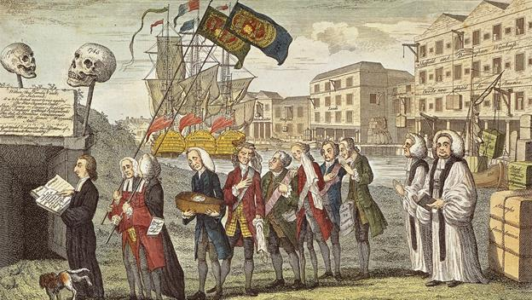

- Mar 22 1915 – WW1: After six months of battle, the Austrian garrison at Przemysl (now in Poland), the citadel guarding the northeastern-most point of the Austro-Hungarian empire, falls to the Russians
- Mar 22 1939 – WW2: Germany takes Memel from Lithuania.
- Mar 22 1942 – WW2: In the Mediterranean Sea, the Royal Navy confronts Italy's Regia Marina in the Second Battle of Sirte.
- Mar 22 1942 – WW2: Heavy German and Italian assault interrupts badly needed resupply of food and ammunition leaving conditions on Malta critical.
- Mar 22 1942 – WW2: Sir Stanford Cripps, British statesman, arrives in India for talks with Mohandas Gandhi on Indian independence, in what will become known as the Cripps Mission.
- Mar 22 1943 – WW2: The entire population (149 people, including 75 children) of Khatyn in the Republic of Belarus near Minsk is burnt alive by the German 118th Schutzmannschaft Nazi battalion occupation force.

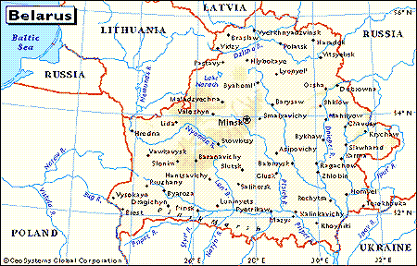

- Mar 22 1945 – WW2: U.S. 3rd Army crosses Rhine at Nierstein.
- Mar 22 1965 – Vietnam: The State Department acknowledges that the United States had supplied the South Vietnamese armed forces with a non-lethal gas which disables temporarily for use “in tactical situations in which the Viet Cong intermingle with or take refuge among non-combatants, rather than use artillery or aerial bombardment.”
- Mar 22 1968 – Vietnam: Gen. William Westmoreland is appointed Army Chief of Staff. Gen. Creighton Abrams replaced him as commander of U.S. forces in Vietnam. As Westmoreland’s successor, Abrams faced the difficult task of implementing the Vietnamization program instituted by the Nixon administration.

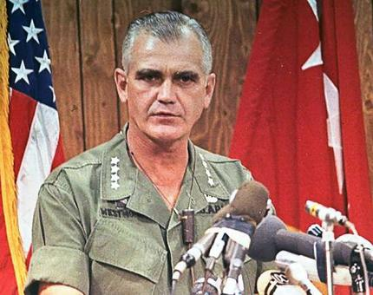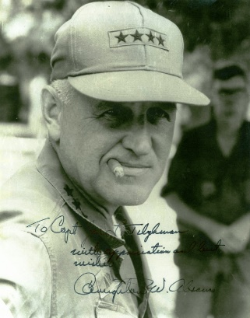
Gen. William Westmoreland Gen. Creighton Abrams

- Mar 23 1775 – Revolutionary War: During a speech before the second Virginia Convention at St. John's Church in Richmond, Patrick Henry responds to the increasingly oppressive British rule over the American colonies by declaring, “I know not what course others may take, but as for me, give me liberty or give me death!”
- Mar 23 1862 – Civil War: The First Battle of Kernstown, Virginia - The battle marked the start of Stonewall Jackson's Valley Campaign. Although his only defeat throughout the war, the engagement distracts Federal efforts to capture Richmond. Casualties and losses: US 500 - CSA 718
- Mar 23 1918 – WW1: At 7:20 in the morning an explosion in the Place de la Republique in Paris announces the first attack of a new German gun. The Pariskanone, or Paris gun, as it came to be known, was manufactured by Krupps; it was 210mm, with a 118-foot-long barrel, which could fire a shell the impressive distance of some 130,000 feet, or 25 miles, into the air. Three of them fired on Paris that day from a gun site at CrÉpy-en-Laonnaise, 74 miles away.

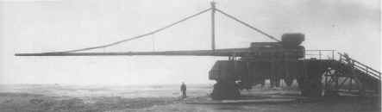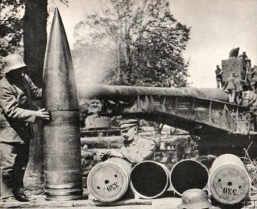

- Mar 23 1919 – Fascism: Benito Mussolini, an Italian World War I veteran and publisher of Socialist newspapers, breaks with the Italian Socialists and establishes the nationalist Fasci di Combattimento, named after the Italian peasant revolutionaries, or “Fighting Bands,” from the 19th century. Commonly known as the Fascist Party, Mussolini’s new right-wing organization advocated Italian nationalism, had black shirts for uniforms, and launched a program of terrorism and intimidation against its leftist opponents.
- Mar 23 1942 – WW2: Japanese forces occupy Andaman Islands in Indian Ocean.
- Mar 23 1942 – WW2: U.S. move native–born of Japanese ancestry into detention centers.
- Mar 23 1944 – WW2: German occupiers shoot more than 300 Italian civilians as a reprisal for an Italian partisan attack on an SS unit. The Italian Resistance had been fighting underground against the fascist government of Mussolini long before its surrender, and now it fought against German fascism.
- Mar 23 1945 – WW2: Largest operation in Pacific war, 1,500 US Navy ships bomb Okinawa.
- Mar 23 1951 – Korea: U.S. paratroopers descend from flying boxcars in a surprise attack in Korea.
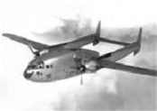
C-119 in flight

- Mar 23 1961 – Vietnam: One of the first American casualties in Southeast Asia, an intelligence-gathering plane en route from Laos to Saigon is shot down over the Plain of Jars in central Laos. The mission was flown in an attempt to determine the extent of the Soviet support being provided to the communist Pathet Lao guerrillas in Laos.
- Mar 23 1983 – Cold War: In an address to the nation, President Ronald Reagan proposes that the United States embark on a program to develop antimissile technology that would make the country nearly impervious to attack by nuclear missiles. Reagan’s speech marked the beginning of what came to be known as the controversial Strategic Defense Initiative (SDI).
- Mar 23 1994 – A United States Air Force (USAF) F–16 aircraft collides with a USAF C–130 at Pope Air Force Base and then crashes, killing 24 United States Army soldiers on the ground. This later became known as the Green Ramp disaster.

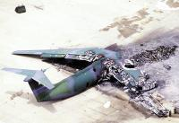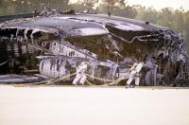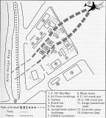

- Mar 23 2003 – Iraq War: In Nasiriyah, 11 soldiers of the 507th Maintenance Company as well as 18 U.S. Marines are killed during the first major conflict of Operation Iraqi Freedom. 654 Iraqi combatants are also killed.
- Mar 24 1765 - American Revolution: British Parliament passes the Quartering Act, outlining the locations and conditions in which their soldiers are to find room and board in the American colonies. The Act required the colonies to house British soldiers in barracks provided by the colonies. If the barracks were too small to house all the soldiers, then localities were to accommodate the soldiers in local inns, livery stables, ale houses, victualling houses, and the houses of sellers of wine. As the language of the act makes clear, the popular image of Redcoats tossing colonists from their bedchambers in order to move in themselves was not the intent of the law; neither was it the practice.
- Mar 24 1862 – Civil War: Abolitionist orator Wendell Phillips is booed while attempting to give a lecture in Cincinnati, Ohio. The angry crowd was opposed to fighting for the freedom of slaves, as Phillips advocated. He was pelted with rocks and eggs before friends whisked him away when a small riot broke out.
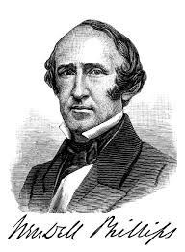
- Mar 24 1918 – WW1: German forces cross the Somme River, achieving their first goal of the major spring offensive begun three days earlier on the Western Front.
- Mar 24 1944 – WW2: In an event later dramatized in the movie The Great Escape, 76 prisoners begin breaking out of Stalag Luft III.
- Mar 24 1944 – WW2: German occupation troops killed 335 people in Rome as a reprisal for a partisan attack conducted on the previous day against the SS Police Regiment Bozen.
- Mar 24 1975 – Vietnam: Despite the 1973 Paris Peace Accords cease fire, the fighting continued between South Vietnamese forces and the North Vietnamese troops in South Vietnam. The launch of the Ho Chi Minh Campaign was the final assault on Saigon. By April 30, the North Vietnamese tanks broke through the gates of the Presidential Palace in Saigon and the Vietnam War came to an end.

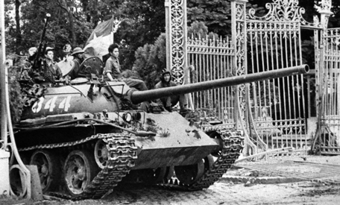

- Mar 24 1977 – Cold War: For the first time since severing diplomatic relations in 1961, Cuba and the United States enter into direct negotiations when the two nations discuss fishing rights. The talks marked a dramatic, but short-lived, change in relations between the two Cold War enemies.
- Mar 24 1999 - Kosovo War: NATO commences aerial bombardment against Yugoslavia, marking the first time NATO has attacked a sovereign country.
- Mar 24 1774 – American Revolution: British Parliament passes the Boston Port Act, closing the port of Boston and demanding that the city’s residents pay for the nearly $1 million worth (in today’s money) of tea dumped into Boston Harbor during the Boston Tea Party of December 16, 1773.
- Mar 25 1865 – Civil War: Battle of Fort Stedman - Confederate General Robert E. Lee makes his last attack of the war in a desperate attempt to break out of Petersburg, Virginia. The attack failed, and within a week Lee was evacuating his positions around Petersburg. Casualties and Losses: The Union lost around 1,000 men killed, wounded, and captured, while Lee lost probably three times that number, including some 1,500 captured during the retreat.
- Mar 25 1915 – 1st submarine disaster. USS F–4 (SS–23) sunk after a battery explosion off Honolulu, Hawaii. 21 died.
- Mar 25 1941 – WW2: Yugoslavia, despite an early declaration of neutrality, signs the Tripartite Pact, forming an alliance with Axis powers Germany, Italy, and Japan.
- Mar 25 1946 – Cold War: In conclusion to an extremely tense situation of the early Cold War regarding Iranian oil, the Soviet Union announces that its troops in Iran will be withdrawn within six weeks. The Iranian crisis was one of the first tests of power between the United States and the Soviet Union in the postwar world.
- Mar 25 1953 – Korean War: The USS Missouri fires on targets at Kojo, North Korea, the last time her guns fire until the Persian Gulf War of 1992.

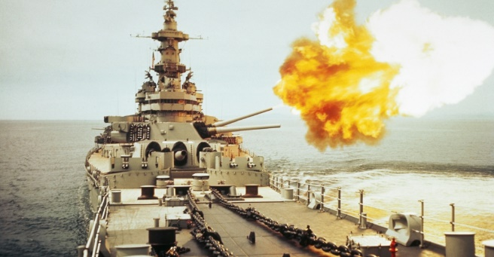
- Mar 25 1967 – Vietnam: The Reverend Martin Luther King, Jr., leads a march of 5,000 antiwar demonstrators in Chicago. In an address to the demonstrators, King declared that the Vietnam War was “a blasphemy against all that America stands for.

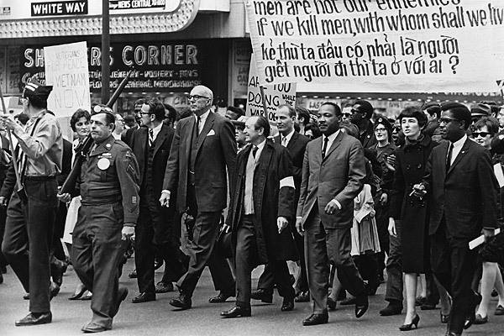

- Mar 25 1968 – Vietnam: Johnson meets with the Wise Men - After being told by Defense Secretary Clark Clifford that the War is a “real loser,” President Johnson, still uncertain about his course of action, decides to convene a nine-man panel of retired presidential advisors. The group, which became known as the “Wise Men,” after two days of deliberation reached a consensus. They advised against any further troop increases and recommended that the administration seek a negotiated peace.
- Mar 25 1971 – Vietnam: The Army of the Republic of Vietnam abandon an attempt to cut off the Ho Chi Minh trail in Laos
- Mar 25 1975 – Vietnam: The former imperial capital of Hue fell to North Vietnamese troops along with the entire Thua Thien Province.
- Mar 25 1994 – Somalia: At the end of a largely unsuccessful 15-month mission, the last U.S. troops depart Somalia, leaving 20,000 U.N. troops behind to keep the peace and facilitate “nation building” in the divided country.
- Mar 26 1776 – American Revolution: The Provincial Congress of South Carolina approves a new constitution and government on this day in 1776. The legislature renames itself the General Assembly of South Carolina and elects John Rutledge as president, Henry Laurens as vice president and William Henry Drayton as chief justice.
- Mar 26 1864 – Civil War: General James B. McPherson assumes command of the Union Army of the Tennessee after William T. Sherman is elevated to commander of the Division of the Mississippi, the overall leader in the West.
- Mar 26 1917 – WWI: First Battle of Gaza - Attempting to advance into Palestine, British were defeated by Ottoman troops. Casualties and losses: GB 3,967 – OE/Ger/AH 1,691
- Mar 26 1941 – WW2: Italy attacks the British fleet at Suda Bay, Crete, using detachable warheads to sink a British cruiser. This was the first time manned torpedoes had been employed in naval warfare, adding a new weapon to the world’s navies’ arsenals.

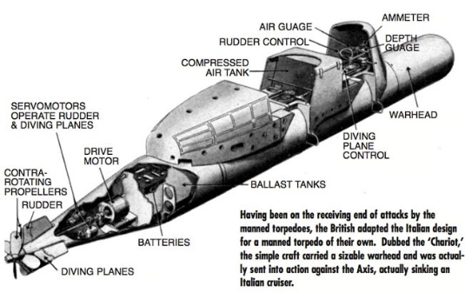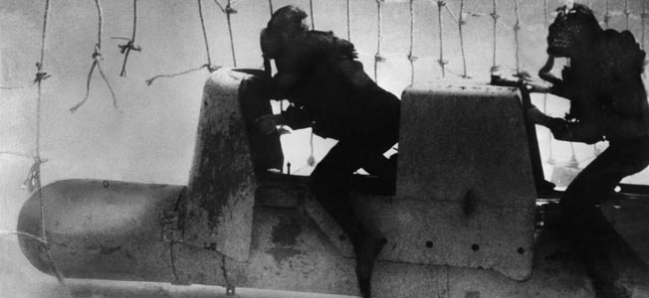
Chariot manned torpedo

- Mar 26 1942 – WW2: The first female prisoners arrive at Auschwitz concentration camp in German-occupied Poland.
- Mar 26 1944 – USS Tullibee (SS–284) accidentally sunk by circular run of own torpedo off Palau Islands. 79 died
- Mar 26 1945 – WW2: Kamikazes attack U.S. battle fleet near Kerama Retto.
- Mar 26 1945 – WW2: U.S. 7th Army crosses Rhine at Worms Germany.
- Mar 26 1945 – WW2: The Battle of Iwo Jima ends as the island is officially secured by American forces.
- Mar 26 1950 – Cold War: During a radio broadcast dealing with a Senate investigation into communists in the U.S. Department of State, news is leaked that Senator Joseph McCarthy has charged Professor Owen Lattimore with being a top spy for the Soviet Union. Lattimore soon became a central figure in the Red Scare hysteria created by McCarthy’s reckless charges and accusations.
- Mar 26 1969 – Vietnam: A group called Women Strike for Peace demonstrate in Washington, D.C., in the first large antiwar demonstration since President Richard Nixon’s inauguration in January. The antiwar movement had initially given Nixon a chance to make good on his campaign promises to end the war in Vietnam. However, it became increasingly clear that Nixon had no quick solution. As the fighting dragged on, antiwar sentiment against the president and his handling of the war mounted steadily during his term in office.
- Mar 26 1970 – 500th nuclear explosion announced by the U.S. since 1945.
- Mar 26 1975 – Vietnam: The city of Hue, in northernmost South Vietnam, falls to the North Vietnamese. Hue was the most recent major city in South Vietnam to fall to the communists during their new offensive. The offensive had started in December 1974, when the North Vietnamese had launched a major attack against the lightly defended province of Phuoc Long, located north of Saigon along the Cambodian border. The communists overran the provincial capital of Phuoc Binh on January 6, 1975.
- Mar 26 1982 – A groundbreaking ceremony for the Vietnam Veterans Memorial is held in Washington, D.C.
- Mar 27 1775 – Future President Thomas Jefferson is elected to the second Continental Congres. Jefferson, a Virginia delegate, quickly established himself in the Continental Congress with the publication of his paper entitled A Summary View of the Rights of British America. Throughout the next year, Jefferson published several more papers, most notably Drafts and Notes on the Virginia Constitution.
- Mar 27 1794 – The U.S. establishes a permanent navy and authorizes the building of 6 frigates.
- Mar 27 1814 – War of 1812: In central Alabama, U.S. forces under General Andrew Jackson defeat the Creek at the Battle of Horseshoe Bend.

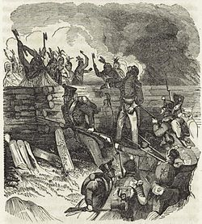
The Battle of Horseshoe Bend

- Mar 27 1836 – Texas Revolution: Goliad massacre – Antonio López de Santa Anna orders the Mexican army to kill about 400 Texas POWs at Goliad, Texas.
- Mar 27 1846 – Mexican–American War: Siege of Fort Texas.
- Mar 27 1865 – Civil War: President Abraham Lincoln meets with Union generals Ulysses S. Grant and William T. Sherman at City Point, Virginia, to plot the last stages of the Civil War.
- Mar 27 1886 – Apache Wars: Famous Apache warrior, Geronimo, surrenders to the U.S. Army, ending the main phase of the Apache Wars.
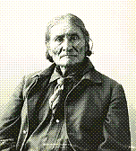
Geronimo, 1898

- Mar 27 1918 – WWI: In the wake of Russia’s withdrawal from World War I and its acceptance of the humiliating peace terms set by the Central Powers at Brest-Litovsk, the Balkan republic of Romania annexes Bessarabia, a strategically important area of land located on its eastern border and bounded on the south by the Danube River and the mouth of the Black Sea.
- Mar 27 1943 – WW2: Battle of the Komandorski Islands - In the Aleutian Islands the battle begins when United States Navy forces intercept Japanese attempting to reinforce a garrison at Kiska.
- Mar 27 1945 – WW2: Gen Eisenhower declares German defenses on Western Front broken.
- Mar 27 1945 – WW2: Iwo Jima occupied, after 22,000 Japanese & 6,000 US killed.
- Mar 27 1945 – WW2: Operation Starvation, the aerial mining of Japan's ports and waterways begins.
- Mar 27 1945 – WW2: In a last-ditch effort to deploy their remaining V-2 missiles against the Allies, the Germans launch their long-range rockets from their only remaining launch site, in the Netherlands. Almost 200 civilians in England and Belgium were added to the V-2 casualty toll.
- Mar 27 1952 – Korea: Elements of the U.S. Eighth Army reach the 38th parallel.
- Mar 27 1965 – Vietnam: Following several days of consultations with the Cambodian government, South Vietnamese troops, supported by artillery and air strikes, launch their first major military operation into Cambodia. The South Vietnamese encountered a 300-man Viet Cong force in the Kandal province and reported killing 53 communist soldiers. Two teams of U.S. helicopter gunships took part in the action. Three South Vietnamese soldiers were killed and seven wounded.
- Mar 27 1973 – Vietnam: The White House announces that, at the request of Cambodian President Lon Nol, the bombing of Cambodia will continue until communist forces cease military operations and agree to a cease-fire.
- Mar 27 1990 – Cold War: The U.S. government begins the operation of TV Marti, which broadcast television programs into communist Cuba. The project marked yet another failed attempt to undermine the regime of Cuban leader Fidel Castro.

Radio Martí broadcast studio

- Mar 28 1794 – American Revolution: Upset by the Boston Tea Party and other blatant acts of destruction of British property by American colonists, the British Parliament enacts the Coercive Acts, to the outrage of American Patriots.
- Mar 28 1862 – American Civil War: Battle of Glorieta Pass – Union forces stop the Confederate invasion of New Mexico territory in the two day battle. Casualties and losses: US 125 - CSA 123
- Mar 28 1915 – WWI: The first American citizen is killed in the eight-month-old European conflict that would become known as the First World War. Leon Thrasher, a 31-year-old mining engineer and native of Massachusetts, drowned when a German submarine, the U-28, torpedoed the cargo-passenger ship Falaba, on its way from Liverpool to West Africa, off the coast of England. Of the 242 passengers and crew on board the Falaba, 104 drowned.
- Mar 28 1941 – WW2: Andrew Browne Cunningham, Admiral of the British Fleet, commands the British Royal Navy’s destruction of three major Italian cruisers and two destroyers in the Battle of Cape Matapan in the Mediterranean. The destruction, following on the attack on the Italian Fleet at Taranto by the British in November 1940, effectively put an end to any threat the Italian navy posed to the British.
- Mar 28 1945 – WW2: Germany launches the last of its V–2 rockets against England.

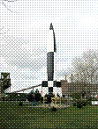
Peenemünde Museum replica of V-2

- Mar 28 1945 – WW2: USS Trigger (SS–237) sunk by Japanese patrol vessel Mikura, Coast Defense Vessel No.33, and Coast Defense Vessel No. 59 in the Nansei Soto. 89 killed.
- Mar 28 1946 – Cold War: The State Department releases the so-called Acheson-Lilienthal Report, which outlines a plan for international control of atomic energy. The report represented an attempt by the United States to maintain its superiority in the field of atomic weapons while also trying to avoid a costly and dangerous arms race with the Soviet Union.
- Mar 28 1961 – Vietnam: A U.S. national intelligence estimate prepared for President John F. Kennedy declares that South Vietnamese President Ngo Dinh Diem and the Republic of Vietnam are facing an extremely critical situation. As evidence, the reports cites that more than half of the rural region surrounding Saigon is under communist control and points to a barely failed coup against Diem the preceding November.
- Mar 28 1967 – Vietnam: The Phoenix, a private U.S. yacht with eight American pacifists aboard, arrives in Haiphong, North Vietnam, with $10,000 worth of medical supplies for the North Vietnamese. The trip, financed by a Quaker group in Philadelphia, was made in defiance of a U.S. ban on American travel to North Vietnam. No charges were filed against the participants and the group made a second trip to North Vietnam later.
- Mar 28 1999 – Kosovo War: Serb paramilitary and military forces kill 146 Kosovo Albanians in the Izbica massacre.

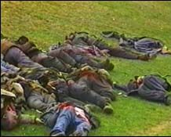

- Mar 28 2003 – In a friendly fire incident, two A-10 Thunderbolt II attack aircraft from the United States Idaho Air National Guard's 190th Fighter Squadron attack British tanks participating in the 2003 invasion of Iraq, killing British soldier Matty Hull.
- Mar 29 1847 – Mexican-American War: United States forces led by General Winfield Scott take Veracruz after a siege.
- Mar 29 1865 – Civil War: Appomattox Campaign - The final campaign of the Civil War begins in Virginia when Union troops under General Ulysses S. Grant move against the Confederate trenches around Petersburg. General Robert E. Lee’s outnumbered Rebels were soon forced to evacuate the city and begin a desperate race west.
- Mar 29 1911 – The M1911 .45 ACP pistol becomes the official U.S. Army side arm.
- Mar 29 1917 – WWI: Prime Minister Hjalmar Hammarskjold of Sweden, father of the famous future United Nations Secretary General Dag Hammarskjold, resigns after his policy of strict neutrality in World War I—including continued trading with Germany, in violation of the Allied blockade—leads to widespread hunger and political instability in Sweden.
- Mar 29 1942 – WW2: The Bombing of Lübeck is the first major success for the RAF Bomber Command against Germany and a German city.
- Mar 29 1944 – WW2: Allied bombing raid on Nuremberg. Along the English eastern coast 795 aircraft are dispatched, including 572 Lancasters, 214 Halifaxes and 9 Mosquitoes. The bombers meet resistance at the coasts of Belgium and the Netherlands from German fighters. In total, 95 bombers are lost, making it the largest Bomber Command loss of World War II.
- Mar 29 1945 – WW2: The German 4th Army is almost destroyed by the Soviet Red Army.
- Mar 29 1945 – WW2: Gen. George S. Patton’s 3rd Army captures Frankfurt, as “Old Blood and Guts” continues his march east.

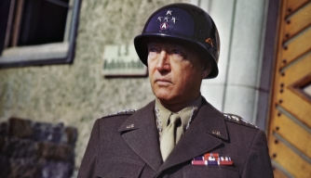
Gen. George S. Patton

- Mar 29 1945 – WW2: Last day of V-1 flying bomb attacks on England.
- Mar 29 1951 – Korea: The Chinese reject Gen. Douglas MacArthur’s offer for a truce in Korea.
- Mar 29 1951 – Cold War: In one of the most sensational trials in American history, Julius and Ethel Rosenberg are convicted of espionage for their role in passing atomic secrets to the Soviets during and after World War II. The husband and wife were later sentenced to death and were executed in 1953.
- Mar 29 1971 – Vietnam: Lt. William L. Calley is found guilty of premeditated murder at My Lai by a U.S. Army court-martial at Fort Benning, Georgia. Calley, a platoon leader, had led his men in a massacre of Vietnamese civilians, including women and children, at My Lai 4, a cluster of hamlets in Quang Ngai Province on March 16, 1968.
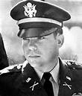
- Mar 29 1973 – Vietnam: Under the provisions of the Paris Peace Accords signed on January 27, 1973, the last U.S. troops depart South Vietnam, ending nearly 10 years of U.S. military presence in that country. The U.S. Military Assistance Command Vietnam headquarters was disestablished. Only a Defense Attache Office and a few Marine guards at the Saigon American Embassy remained, although roughly 8,500 U.S. civilians stayed on as technical advisers to the South Vietnamese.
- Mar 30 1775 – American Revolution: Hoping to keep the New England colonies dependent on the British, King George III formally endorses the New England Restraining Act. The Act required New England colonies to trade exclusively with Great Britain as of 1 JUL. An additional rule would come into effect on 20 JUL, banning colonists from fishing in the North Atlantic.
- Mar 30 1918 – WWI: Battle of Moreuil Wood - British, Australian and Canadian troops mount a successful counter-attack against the German offensive recapturing most of the area and forcing a turn in the tide of the battle in favor of the Allies.
- Mar 30 1940 – WW2: Japan establishes its own government in conquered Nanking, the former capital of Nationalist China. Nanking was declared by the Japanese to be the center of a new Chinese government, a regime controlled by Wang Ching-wei, a defector from the Nationalist cause and now a Japanese puppet.
- Mar 30 1944 – WW2: The U.S. fleet attacks Palau, near the Philippines.
- Mar 30 1948 – Cold War: The Henry Wallace, former vice-president and current Progressive Party presidential candidate, lashes out at the Cold War policies of President Harry S. Truman. Wallace and his supporters were among the few Americans who actively voiced criticisms of America’s Cold War mindset during the late-1940s and 1950s.
- Mar 30 1965 – Vietnam: A bomb explodes in a car parked in front of the U.S. Embassy in Saigon, virtually destroying the building and killing 19 Vietnamese, 2 Americans, and 1 Filipino; 183 others were injured. Congress quickly appropriated $1 million to reconstruct the embassy. Although some U.S. military leaders advocated special retaliatory raids on North Vietnam, President Lyndon B. Johnson refused.

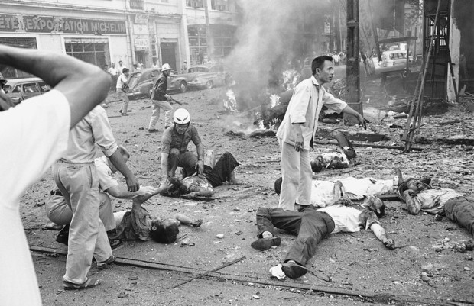
Injured Vietnamese receive aid as they lie on the street after a bomb explosion outside the U.S. Embassy in Saigon, Vietnam, March 30, 1965

- Mar 30 1972 – Vietnam: The Easter Offensive begins with Hanoi launching its heaviest attack in four years, crossing into the DMZ. A major coordinated communist offensive opens with the heaviest military action since the sieges of Allied bases at Con Thien and Khe Sanh in 1968. Committing almost their entire army to the Easter offensive, the North Vietnamese launched a massive three-pronged attack into South Vietnam. Four North Vietnamese divisions attacked directly across the Demilitarized Zone in Quang Tri province. Thirty-five South Vietnamese soldiers died in the initial attack and hundreds of civilians and soldiers were wounded.
- Mar 31 1776 – American Revolution: Abigail Adams writes to her husband, John Adams, urging him and the other members of the Continental Congress not to forget about the nation’s women when fighting for America’s independence from Great Britain.
- Mar 31 1865 – Civil War: The final offensive of the Army of the Potomac gathers steam when Union General Philip Sheridan moves against the left flank of Confederate General Robert E. Lee’s Army of Northern Virginia near Dinwiddie Court House. The limited action set the stage for the Battle of Five Forks, Virginia, on 1 APR.
- Mar 31 1905 – WWI: Kaiser Wilhelm of Germany arrives in Tangiers to declare his support for the sultan of Morocco, provoking the anger of France and Britain in what will become known as the First Moroccan Crisis, a foreshadowing of the greater conflict between Europe’s great nations still to come, the First World War.
- Mar 31 1940 – WW2: The German auxiliary cruiser Atlantis sets off on a mission to catch and sink Allied merchant ships. By the time the Atlantis set sail from Germany, the Allies had already lost more than 750,000 tons worth of shipping, the direct result of German submarine attacks. They had also lost another 281,000 tons because of mines, and 36,000 tons as the result of German air raids. The Germans had lost just eighteen submarines.

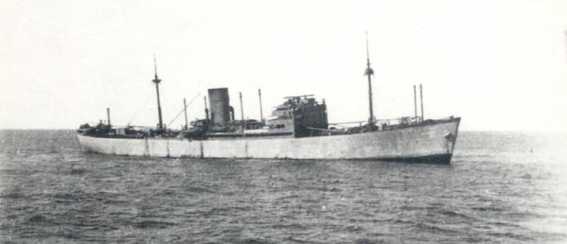

- Mar 31 1941 – WW2: Germany begins a counter offensive in Africa.
- Mar 31 1965 – Vietnam: Responding to questions from reporters about the situation in Vietnam, President Johnson says, “I know of no far-reaching strategy that is being suggested or promulgated.” Early in the month, Johnson had sent 3,500 Marines to Da Nang to secure the U.S. airbase there. These troops were ostensibly there only for defensive purposes, but Johnson, despite his protestations to the contrary, was already considering giving the authorization for the U.S. troops to go from defensive to offensive tactics.
- Mar 31 1968 – Vietnam: In a televised speech to the nation, President Lyndon B. Johnson announces a partial halt of bombing missions over North Vietnam and proposes peace talks. He said he had ordered “unilaterally” a halt to air and naval bombardments of North Vietnam “except in the area north of the Demilitarized Zone, where the continuing enemy build-up directly threatens Allied forward positions.”
- Mar 31 1972 – Vietnam: After firing more than 5,000 rockets, artillery, and mortar shells on 12 South Vietnamese positions just below the Demilitarized Zone, the North Vietnamese Army launches ground assaults against South Vietnamese positions in Quang Tri Province. The attacks were thrown back, with 87 North Vietnamese killed
- Mar 31 1991 – Cold War: After 36 years in existence, the Warsaw Pact—the military alliance between the Soviet Union and its eastern European satellites—comes to an end. The action was yet another sign that the Soviet Union was losing control over its former allies and that the Cold War was falling apart.

[Source: http://www.history.com/this-day-in-history | March 2018 ++]

