Military History Anniversaries 1 thru 15 January

Events in History over the next 15 day period that had U.S. military involvement or impacted in some way on U.S military operations or American interests

- Jan 00 1944 – WW2: USS Scorpion (SS–278). Date of sinking unknown. Most likely a Japanese mine in Yellow or East China Sea. 77 killed.
- Jan 00 1945 – WW2: USS Swordfish (SS–193) missing. Possibly sunk by Japanese Coast Defense Vessel No. 4 on 5 January or sunk by a mine off Okinawa on 9 January. 89 killed.
- Jan 01 1781 – American Revolution: Mutiny of the Pennsylvania Line – 1,500 soldiers from the Pennsylvania Line (all 11 regiments under General Anthony Wayne’s command) insist that their three-year enlistments are expired, kill three officers in a drunken rage and abandon the Continental Army’s winter camp at Morristown, New Jersey.
- Jan 01 1883 – Civil War: President Abraham Lincoln signs the final Emancipation Proclamation, which ends slavery in the rebelling states. The proclamation freed all slaves in states that were still in rebellion as of 1 JAN.
- Jan 01 1915 – WWI: The 15,000-ton British HMS class battleship Formidable is torpedoed by the German submarine U-24 and sinks in the English Channel, killing 547 men. The Formidable was part of the 5th Battle Squadron unit serving with the Channel Fleet.

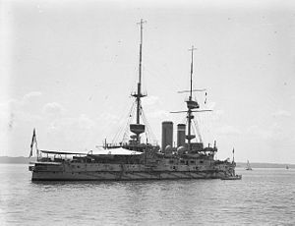

- Jan 01 1942 – WW2: The War Production Board (WPB) ordered the temporary end of all civilian automobile sales leaving dealers with one half million unsold cars.
- Jan 01 1942 – WW2: United Nations – President Franklin D. Roosevelt and British Prime Minister Winston Churchill issue a declaration, signed by representatives of 26 countries, called the “United Nations.” The signatories of the declaration vowed to create an international postwar peacekeeping organization.
- Jan 01 1945 – WW2: In Operation Bodenplatte, German planes attack American forward air bases in Europe. This is the last major offensive of the Luftwaffe.
- Jan 01 1946 – WW2: An American soldier accepts the surrender of about 20 Japanese soldiers who only discovered that the war was over by reading it in the newspaper.
- Jan 01 1959 – Cuba: Facing a popular revolution spearheaded by Fidel Castro’s 26th of July Movement, Us. Supported Cuban dictator Fulgencio Batista flees the island nation.

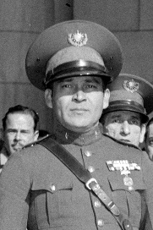

- Jan 01 1966 – Vietnam: Advance elements of the 1st Regiment of the Marine 1st Division arrive in Vietnam. The entire division followed by the end of March.
- Jan 01 1967 – Vietnam: Operation Sam Houston begins as a continuation of border surveillance operations in Pleiku and Kontum Provinces in the Central Highlands by units from the U.S. 4th and 25th Infantry Divisions.
- Jan 02 1777 – American Revolution: American forces under the command of George Washington repulsed a British attack at the Battle of the Assunpink Creek near Trenton, New Jersey. Casualties and losses: US 7 to 100 - GB 55 to 365.
- Jan 02 1791 – Big Bottom massacre (11 killed) in the Ohio Country, marking the beginning of the Northwest Indian War.
- Jan 02 1863 – Civil War: Battle of Stones River – Union troops of William Rosecrans defeat Confederates under Braxton Bragg at Murfeesboro, Tennessee, just south of Nashville. The battle was a crucial engagement in the contest for central Tennessee, and provided a Union victory during a bleak period for the North.
- Jan 02 1904 – Latin America Interventions: U.S. Marines are sent to Santo Domingo to aid the government against rebel forces.
- Jan 02 1942 – The Federal Bureau of Investigation (FBI) convicts 33 members of a German spy ring headed by Fritz Joubert Duquesne in the largest espionage case in United States history-the Duquesne Spy Ring.
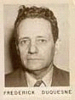

- Jan 02 1942 – WW2: In the Philippines, the city of Manila and the U.S. Naval base at Cavite fall to Japanese forces.
- Jan 02 1942 – WW2: The Navy Airship Patrol Group 1 and Air Ship Squadron 12 are established at Lakehurst, N.J. The U.S. Navy was the only military service in the world to use airships–also known as blimps–during the war.
- Jan 02 1945 – WW2: Nuremberg, Germany is 90% destroyed by Allied bombers. 1,800 residents killed and roughly 100,000 displaced.
- Jan 02 1947 – Subsequent Nuremberg Trials: Former Field Marshal Erhard Milch of the Luftwaffe was accused of having committed war crimes and crimes against humanity. He was found guilty on 2 of 3 counts and sentenced to life imprisonment.

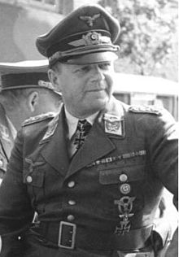

- Jan 02 1963 - Vietnam: The Viet Cong wins its first major victory in the Battle of Ap Bac. Casualties and losses: NLF 57 - US & ARVN 194
- Jan 02 1966 – Vietnam: American forces move into the Mekong Delta for the first time.
- Jan 02 1967 – Vietnam: In what is described as the biggest air battle of the war to date, U.S. Air Force F-4 Phantom jets down seven communist MiG-21s over North Vietnam.
- Jan 02 1980 – Cold War: President Carter ends Russian Detente – In a strong reaction to the December 1979 Soviet invasion of Afghanistan, President Jimmy Carter asks the Senate to postpone action on the SALT II nuclear weapons treaty and recalls the U.S. ambassador to Moscow. These actions sent a message that the age of detente and the friendlier diplomatic and economic relations that were established between the United States and Soviet Union during President Richard Nixon’s administration (1969-74) had ended.
- Jan 03 1777 – American Revolution: Battle of Princeton – American general George Washington defeats British general Charles Cornwallis. Casualties and losses: US 55 to 84 - GB 240 to 450.
- Jan 03 1834 – Mexican War: Escalating the tensions that would lead to rebellion and war, the Mexican government imprisons the Texas colonizer Stephen Austin in Mexico City.
- Jan 03 1920 – WWI: The last of the U.S. troops depart France.
- Jan 03 1944 – WW2: Top Ace Major Greg "Pappy" Boyington is shot down in his Corsair by Captain Masajiro Kawato flying a Zero.

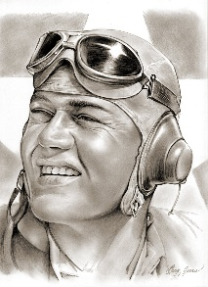
- Jan 03 1945 – WW2: In preparation for planned assaults against Iwo Jima, Okinawa, and mainland Japan, Gen. Douglas MacArthur is placed in command of all U.S. ground forces and Adm. Chester Nimitz is placed in command of all U.S. naval forces. This effectively ended the concept of unified commands, in which one man oversaw more than one service from more than one country in a distinct region.
- Jan 03 1961 – Cuba: In the climax of deteriorating relations between the United States and Fidel Castro’s government in Cuba, President Dwight D. Eisenhower closes the American embassy in Havana and severs diplomatic relations.
- Jan 03 1990 – Panama: General Manuel Antonio Noriega, after holing up for 10 days at the Vatican embassy in Panama City, surrenders to U.S. military troops to face charges of drug trafficking.

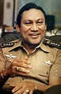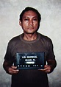

- Jan 04 1796 – American Revolution: The House of Representatives accepts the Colors, or flag, of the French Revolutionary Republic, proclaiming it the most honorable testimonial of the existing sympathies and affections of the two Republics.
- Jan 04 1944 – WW2: Operation Carpetbag. U.S. aircraft begin dropping supplies to guerrilla forces throughout Western Europe. The action demonstrated that the U.S. believed guerrillas were a vital support to the formal armies of the Allies in their battle against the Axis powers.
- Jan 04 1951 – Korea: Chinese communist forces recapture Seoul from United Nations troops, the second time the South Korean capital fell under Communist rule in roughly half a year

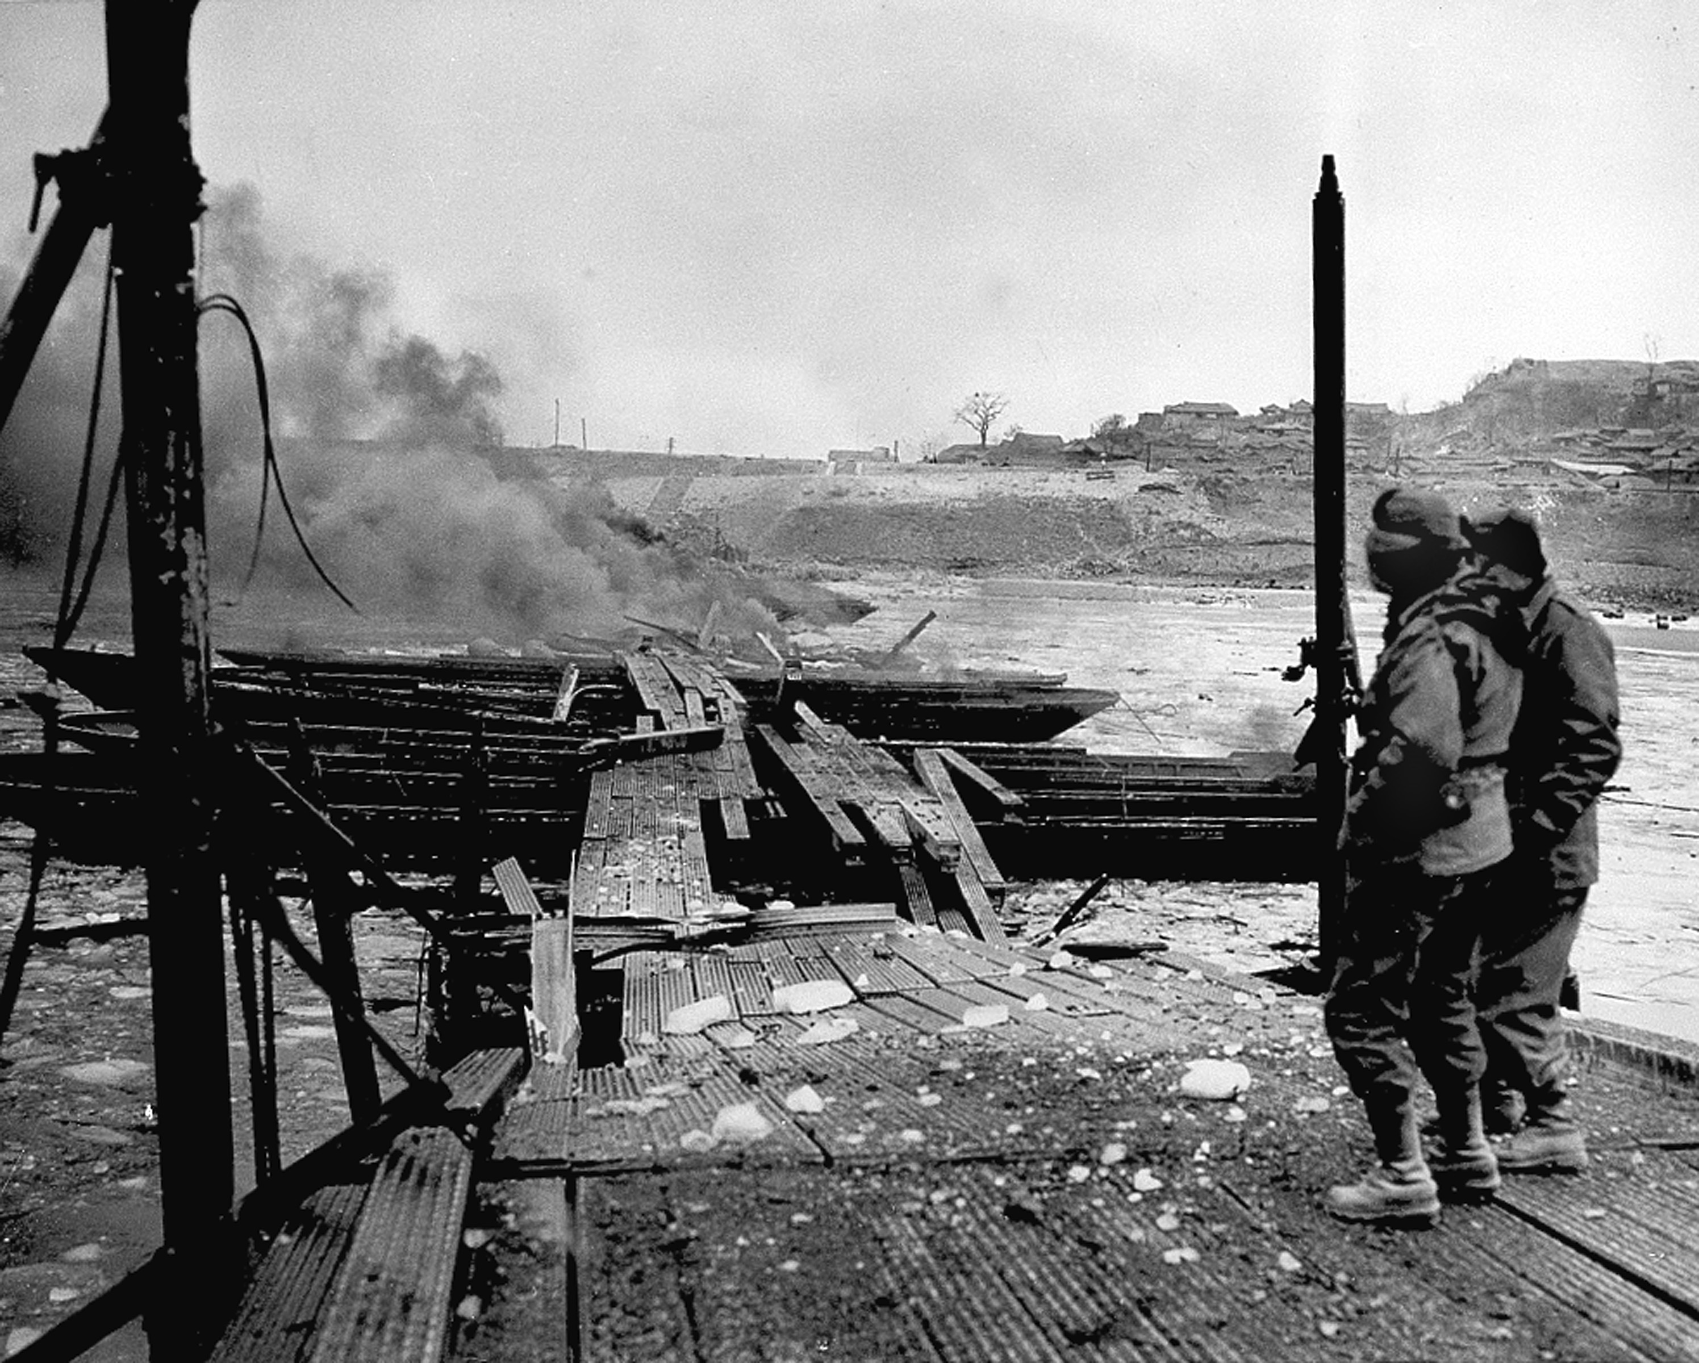
U.N. troops watch flames consume a pontoon bridge across the ice-choked Han River in South Korea. The crossing was dynamited following abandonment of the South Korean capital. The Communist North Koreans came across the stream in close pursuit of the retreating Allied force

- Jan 04 1989 – Second Gulf of Sidra incident: A pair of Libyan MiG-23 "Floggers" are shot down by a pair of US Navy F-14 Tomcats during an air-to-air confrontation.

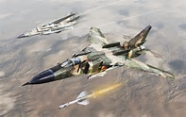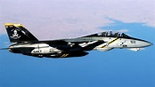
MIG-23 F-14

- Jan 05 1781 – American Revolution: Richmond, Virginia, is burned by British naval forces led by Benedict Arnold. After the war, Benedict Arnold attempted and failed to establish businesses in Canada and London. He died a pauper on June 14, 1801, and lays buried in his Continental Army uniform at St. Mary’s Church, Middlesex, London. To this day, his name remains synonymous with the word “traitor” in the United States.
- Jan 05 1904 – American Marines arrive in Seoul, Korea, to guard the U.S. legation there.
- Jan 05 1942 – WW2: U.S. and Filipino troops complete their withdrawal to a new defensive line along the base of the Bataan peninsula.
- Jan 05 1945 – WW2: Japanese pilots received the first order to become kamikaze, meaning “divine wind” in Japanese. The suicidal blitz of the kamikazes revealed Japan’s desperation in the final months of World War II. Most of Japan’s top pilots were dead, but youngsters needed little training to take planes full of explosives and crash them into ships. At Okinawa, they sank 30 ships and killed almost 5,000 Americans.
- Jan 05 1951 – Korea: Inchon, South Korea, the sight of General Douglas MacArthur’s amphibious flanking maneuver, is abandoned by U.N. force to the advancing Chinese Army.
- Jan 05 1951 – Cold War: In response to the increasingly tense situation in the Middle East, President Dwight D. Eisenhower delivers a proposal to Congress that calls for a new and more proactive U.S. policy in the region. The “Eisenhower Doctrine,” as the proposal soon came to be known, established the Middle East as a Cold War battlefield.
- Jan 05 1967 – Vietnam: 1st Battalion, 9th U.S. Marines and South Vietnamese Marine Brigade Force Bravo conduct amphibious operations in the Kien Hoa Province in the Mekong Delta, located 62 miles south of Saigon. This action, part of Operation Deckhouse V, marked the first time that U.S. combat troops were used in the Mekong Delta.
- Jan 06 1777 – American Revolution: After two significant victories over the British in Trenton and Princeton, New Jersey, General George Washington marches north to Morristown, New Jersey, where he set up winter headquarters for himself and the men of the Continental Army.
- Jan 06 1941 – WW2: President Franklin D. Roosevelt asks Congress to support the Lend–lease Bill to help supply the Allies.

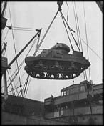
"How lend-lease strikes at the Axis," ca. 1940–45.

- Jan 06 1942 – WW2: President Franklin D. Roosevelt announces to Congress that he is authorizing the largest armaments production in the history of the United States.
- Jan 06 1958 – Cold War: The Soviet Union announces plans to cut the size of its standing army by 300,000 troops in the coming year. The reduction was part of a 1956 policy announced by Khrushchev in anticipation of “peaceful coexistence” with the West, and an indication that Cold War relations between the United States and the Soviet Union were undergoing a slight thaw in the mid- to late-1950s.
- Jan 06 1967 – Vietnam: United States Marine Corps and ARVN troops launch 'Operation Deckhouse Five' in the Mekong River delta. Casualties and losses: (KIA) US 7 - Vietcong 21
- Jan 06 1971– Vietnam: The Army drops charges of an alleged cover-up in the My Lai massacre against four officers. After the charges were dropped, a total of 11 people had been cleared of responsibility during the My Lai trials.
- Jan 06 1975 – Vietnam: Battle of Phuoc Long - Phuoc Binh falls to the North Vietnamese. Casualties and losses: ARVN 5604 - NVA & VC 1300
- Jan 07 1942 – WW2: The siege of the Bataan Peninsula begins.
- Jan 07 1944 – WW2: The U.S. Air Force announces the production of the first jet fighter, Bell P-59 Airacomet.
- Jan 07 1945 – WW2: British Gen. Bernard Montgomery gives a press conference in which he all but claims complete credit for saving the Allied cause in the Battle of the Bulge. He was almost removed from his command because of the resulting American outcry.

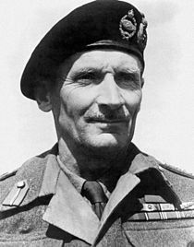

- Jan 07 1948 – Kentucky Air National Guard pilot Thomas Mantell crashes while in pursuit of a supposed UFO.
- Jan 07 1953 – Cold War: In his final State of the Union address before Congress, President Harry S. Truman tells the world that that the United States has developed a hydrogen bomb.
- Jan 07 1959 – Cold War: Just six days after the fall of the Fulgencio Batista dictatorship in Cuba, U.S. officials recognize the new provisional government of the island nation. Despite fears that Fidel Castro, whose rebel army helped to overthrow Batista, might have communist leanings, the U.S. government believed that it could work with the new regime and protect American interests in Cuba.
- Jan 07 1960 – The Polaris missile is test launched.
- Jan 07 1948 – Kentucky Air National Guard pilot Thomas Mantell crashes while in pursuit of a supposed UFO.
- Jan 07 1975 – Vietnam: Vietnamese troops take Phuoc Binh in new full-scale offensive.
- Jan 08 1815 – War of 1812: Battle of New Orleans – A ragtag army under Andrew Jackson defeats the British on the fields of Chalmette in the Battle of New Orleans. Casualties and losses: US 333 - UK 2,459.
- Jan 08 1863 – Civil War: Second Battle of Springfield ends with a Confederate withdrawal. Casualties and losses: US 231 CSA ~290.
- Jan 08 1877 – Crazy Horse and his warriors fight their last battle with the United States Cavalry
at Wolf Mountain (Montana Territory).

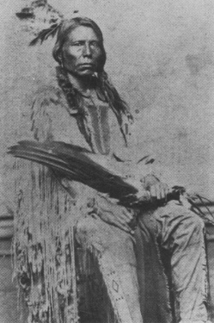

- Jan 08 1916 – WW1: Allied forces stage a full retreat from the shores of the Gallipoli Peninsula in Turkey, ending a disastrous invasion of the Ottoman Empire. The Gallipoli Campaign resulted in 250,000 Allied casualties and greatly discredited Allied military command. Roughly an equal number of Turks were killed or wounded.
- Jan 08 1918 – President Woodrow Wilson announces his "Fourteen Points" for the aftermath of WWI.
- Jan 08 1940 – WW2: A message from Benito Mussolini is forwarded to Adolf Hitler. In the missive, the Duce cautions the Fuhrer against waging war against Britain. Mussolini asked if it was truly necessary “to risk all-including the regime-and to sacrifice the flower of German generations.”
- Jan 08 1945 – WW2: Philippine Commonwealth troops under the Philippine Commonwealth Army units enter the province of Ilocos Sur in Northern Luzon and attack Japanese Imperial forces.
- Jan 08 1967 – Vietnam: Operation Cedar Falls. Over 16,000 U.S. and 14,000 Vietnamese troops start their biggest attack on the Iron Triangle, northwest of Saigon. Casualties and losses: US/ARVN 428 - NVA/VC 1030 (US Claim)
- Jan 08 2005 – The nuclear sub USS San Francisco collides at full speed with an undersea mountain south of Guam. One man is killed, but the sub surfaces and is repaired.
- Jan 09 1861 – Civil War: The "Star of the West" incident occurs near Charleston, South Carolina. It is considered by some historians to be the "First Shots of the American Civil War".
- Jan 09 1863 – Civil War: The 3 day Battle of Fort Hindman begins in Arkansas. Casualties and losses: US 1,061 - CSA ~5,000

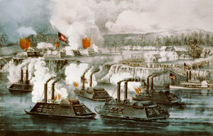
Bombardment and capture of Fort Hindman, Arkansas Post, Ark

- Jan 09 1918 – Indian Wars: Battle of Bear Valley - The last battle of the American Indian Wars. Casualties and losses: US 0 - Yaqui 10
- Jan 09 1945 – WW2: Gen. Douglas MacArthur and the American 6th Army land on the Lingayen Gulf of Luzon, 107 miles from Manila. Another step in the capture of the Philippine Islands from the Japanese.
- Jan 09 1952 – Cold War: In his State of the Union address, President Harry S. Truman warns Americans that they are “moving through a perilous time,” and calls for vigorous action to meet the communist threat.
- Jan 09 1991 – Representatives from the United States and Iraq meet at the Geneva Peace Conference to try to find a peaceful resolution to the Iraqi invasion of Kuwait.
- Jan 10 1776 – American Revolution: While in exile aboard a warship in Cape Fear, North Carolina’s Royal Governor Josiah Martin issues a proclamation calling on the king’s loyal subjects to raise an armed force to combat the rebels, raise the royal standard and restore the province to its former glorious freedom.
- Jan 10 1847 – Mexican War: General Stephen Kearny and Commodore Robert Stockton retake Los Angeles in the last California battle of the war.
- Jan 10 1920 – WWI: The League of Nations formally comes into being when the Covenant of the League of Nations, ratified by 42 nations in 1919, takes effect.
- Jan 10 1923 – WWI: Four years after the end of World War I, President Warren G. Harding orders U.S. occupation troops stationed in Germany to return home.
- Jan 10 1941 – WW2: President Franklin D. Roosevelt’s Lend-Lease program is brought before the U.S. Congress for consideration. Roosevelt devised the Lend-Lease program as a means of aiding Great Britain in its war effort against the Germans.
- Jan 10 1943 – WW2: USS Argonaut (APS–1) sunk by aircraft (582d Kokutai) and Japanese destroyers Isokaze and Maikaze southeast of New Britain in Solomon Sea. 104 killed
- Jan 10 1967 – Vietnam: President Johnson asks for enactment of a 6 percent surcharge on personal and corporate income taxes to help support the Vietnam War for two years, or “for as long as the unusual expenditures associated with our efforts continue.” Congress delayed for almost a year, but eventually passed the surcharge. The U.S. expenditure in Vietnam for fiscal year 1967 would be $21 billion.
- Jan 11 1863 – Civil War: The Battle of Fort Hindman (i.e. Arkansas Post) Arkansas ends with a Union victory and capture of the Arkansas River. Casualties and losses: US 1,061 - CSA ~5,500
- Jan 11 1863 – Civil War: CSS Alabama encountered and sank the USS Hatteras (1861) off Galveston Lighthouse in Texas. Casualties and losses: US 125 CSA 2.
- Jan 11 1916 – WWI: To provide a safe and stable haven for the growing number of refugees pouring out of the devastated Balkan state of Serbia, French forces take formal military control of the Greek island of Corfu.
- Jan 11 1940 – Benjamin O. Davis, Sr., becomes the U.S. Army’s first black general, his son would later become a general as well.

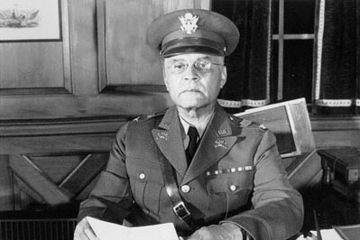

- Jan 11 1956 – Vietnam: South Vietnamese President Ngo Dinh Diem issues Ordinance No. 6, allowing the internment of former Viet Minh members and others “considered as dangerous to national defense and common security.”
- Jan 11 1967 – Vietnam: Operation Deckhouse Five, a combined USMC and ARVN troop effort in the Mekong River delta ends in failure.
- Jan 12 1991 – Gulf War: An act of the U.S. Congress authorizes the use of military force to drive Iraq out of Kuwait.
- Jan 12 1846 – Mexican War: President James Polk dispatches General Zachary Taylor and 4,000 troops to the Texas Border as war with Mexico looms.
- Jan 12 1919 – WWI: The day after British Prime Minister David Lloyd George’s arrival in Paris, he meets with representatives from the other Big Four nations—Prime Ministers Georges Clemenceau of France and Vittorio Orlando of Italy and President Woodrow Wilson of the United States—at the French Foreign Ministry on the Quai d’Orsay, for the first of what will be more than 100 meetings.
- Jan 12 1942 – WW2: President Franklin D. Roosevelt reinstates Woodrow Wilson’s National War Labor Board (NWLB) in an attempt to forestall labor-management conflict during World War II.
- Jan 12 1943 – WW2: Soviet troops create a breach in the German siege of Leningrad, which had lasted for a year and a half. The Soviet forces punched a hole in the siege, which ruptured the German encirclement and allowed for more supplies to come in along Lake Ladoga.
- Jan 12 1954 – Cold War: Secretary of State John Foster Dulles announces that the United States will protect its allies through the “deterrent of massive retaliatory power.” The policy announcement was further evidence of the Eisenhower administration’s decision to rely heavily on the nation’s nuclear arsenal as the primary means of defense against communist aggression.

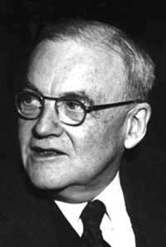

- Jan 12 1962 – Vietnam: Operation Chopper, the first American combat mission in the war, takes place. Casualties and losses: US none - NLF 6.
- Jan 12 1962 – Vietnam: Operation Ranch Hand initiated which lasted until 1972. It involved spraying an estimated 20 million gallons of defoliants and herbicides over rural areas of South Vietnam in an attempt to deprive the Vietnamese people of food and vegetation cover.
- Jan 12 1966 – Vietnam: Lyndon Johnson, in his State of the Union address, commits the United States to staying in Vietnam as long as aggression commands us to battle. Johnson justified his position on the basis of national security and the principles of democracy and national sovereignty.
- Jan 12 1991 – Gulf War: An act of the U.S. Congress authorizes the use of military force to drive Iraq out of Kuwait.
- Jan 13 1991 – American Revolution: British forces raid Prudence Island, Rhode Island, in an effort to steal a large quantity of sheep. But, upon landing on the island’s southern beaches, the British were ambushed by fifteen Minutemen from Rhode Island’s Second Company led by Captain Joseph Knight, who had been tipped off to the Brits’ plans and rowed across Narragansett Bay from Warwick Neck the previous morning.
- Jan 13 1815 – War of 1812: British troops capture Fort Peter in St. Marys, Georgia, the only battle of the war to take place in the state.
- Jan 13 1847 – The Treaty of Cahuenga ends the Mexican–American War in California.
- Jan 13 1893 – U.S. Marines land in Honolulu from the U.S.S. Boston to prevent the queen from abrogating the Bayonet Constitution.
- Jan 13 1942 – WW2: Representatives of nine German-occupied countries meet in London to declare that all those found guilty of war crimes would be punished after the war ended.
- Jan 13 1950 – Cold War: For the second time in a week, Jacob Malik, the Soviet representative to the United Nations, storms out of a meeting of the Security Council, this time in reaction to the defeat of his proposal to expel the Nationalist Chinese representative. At the same time, he announced the Soviet Union’s intention to boycott further Security Council meetings.
- Jan 13 1962 – Vietnam: In the first Farm Gate combat missions, T-28 fighter-bombers are flown in support of a South Vietnamese outpost under Viet Cong attack. By the end of the month, U.S. Air Force pilots had flown 229 Farm Gate sorties.
- Jan 13 1968 – Vietnam: U.S. reports shifting most air targets from North Vietnam to Laos.
- Jan 13 1972 – Vietnam: President Nixon announces that 70,000 U.S. troops will leave South Vietnam over the next three months, reducing U.S. troop strength there by 1 MAY to 69,000 troops.
- Jan 14 1784 – American Revolution: Ratification Day, United States - Congress ratifies the Treaty of Paris with Great Britain ending hostilities between the two countries. The other combatant nations, France, Spain and the Dutch Republic had separate agreements.
- Jan 14 1860 – Civil War: Unable to agree on anything else, the U.S. House of Representatives’ Committee of Thirty-Three submits a proposed constitutional amendment protecting slavery in all areas where it already existed. The proposed measure was not enough to stem the tide of seceding states.
- Jan 14 1911 – The USS Arkansas, the largest U.S. battleship, is launched from the yards of the New York Shipbuilding Company.
- Jan 15 1915 – WWI: As part of an attempt to display its loyalty to the British empire and, perhaps more importantly, enlarge its own sphere of influence on the African continent, South Africa sends troops to occupy Swakopmund, a seaside town in German-occupied Southwest Africa (modern-day Namibia).
- Jan 14 1942 – WW2: President Franklin D. Roosevelt issues Presidential Proclamation No. 2537, requiring aliens from World War II-enemy countries–Italy, Germany and Japan–to register with the United States Department of Justice. Registered persons were then issued a Certificate of Identification for Aliens of Enemy Nationality. A follow-up to the Alien Registration Act of 1940, Proclamation No. 2537 facilitated the beginning of full-scale internment of Japanese Americans the following month.
- Jan 14 1942 – WW2: The United States and Great Britain agree to have the British Chiefs of Staff and the U.S. Joint Chiefs work together, either through meetings or representatives, to advise the leaders of both nations on military policy during the war.
- Jan 14 1943 – WW2: Operation Ke, the successful Japanese operation to evacuate their forces from Guadalcanal during the Guadalcanal campaign, begins.
- Jan 14 1943 – WW2: Franklin D. Roosevelt and Winston Churchill begin the Casablanca Conference to discuss strategy and study the next phase of the war.

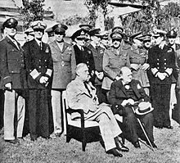

- Jan 14 1950 – The first prototype of the MiG-17 makes its maiden flight.
- Jan 14 1968 – Vietnam: Operation Niagara – A U.S. joint-service operation is launched to support the U.S. Marine base at Khe Sanh. The base was the westernmost anchor of a series of combat bases and strongholds that stretched from the Cua Viet River on the coast of the South China Sea westward along Route 9 to the Laotian border
- Jan 14 1969 – An accidental explosion aboard the USS Enterprise (CVN-65) near Hawaii kills 27 people.
- Jan 14 1980 – Cold War: In a crushing diplomatic rebuke to the Soviet Union, the U.N. General Assembly votes 104 to 18 to “deplore” the Russian intervention in Afghanistan. The resolution also requested the “immediate, unconditional and total withdrawal of the foreign troops from Afghanistan.”
- Jan 15 1815 – War of 1812: American frigate USS President, commanded by Commodore Stephen Decatur, is captured by a squadron of four British frigates.
- Jan 15 1865 – Civil War: Fort Fisher North Carolina falls to the Union, thus cutting off the last major seaport of the Confederacy. Casualties and losses: US 1,341 - CSA ~1,500.
- Jan 15 1919 – WWI: A coup launched in Berlin by a group of radical socialist revolutionaries is brutally suppressed by right-wing paramilitary units from January 10 to January 15, 1919; the group’s leaders, Karl Liebknecht and Rosa Luxemburg, are murdered.
- Jan 15 1943 – The world's largest office building, The Pentagon, is dedicated in Arlington, Virginia.
- Jan 15 1944 – WW2: The U.S. Fifth Army successfully breaks the German Winter Line in Italy with the capture of Mount Trocchio.

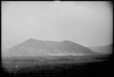

- Jan 15 1951 – WW2: Ilse Koch, wife of the commandant of the Buchenwald concentration camp, is sentenced to life imprisonment in a court in West Germany. Ilse Koch was nicknamed the “Witch of Buchenwald” for her extraordinary sadism.

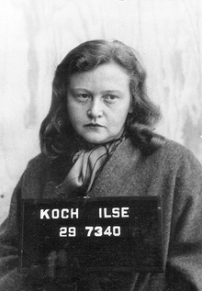

- Jan 15 1953 – Cold War: Testifying before the Senate Foreign Relations Committee prior to taking office as the new secretary of state, John Foster Dulles argues that U.S. foreign policy must strive for the “liberation of captive peoples” living under communist rule. Though Dulles called for a more vigorous anticommunist policy, he remained vague about exactly how the “liberation” would take place.
- Jan 15 1962 – Vietnam: Asked at a news conference if U.S. troops are fighting in Vietnam, President Kennedy answers “No.” He was technically correct, but U.S. soldiers were serving as combat advisers with the South Vietnamese army, and U.S. pilots were flying missions with the South Vietnamese Air Force.
- Jan 15 1973 – Vietnam: Citing progress in peace negotiations, President Richard Nixon announces the suspension of offensive action in North Vietnam.
- Jan 15 1991 – The United Nations deadline for the withdrawal of Iraqi forces from occupied Kuwait expires, preparing the way for the start of Operation Desert Storm.

[Source: http://www.history.com/this-day-in-history | This Day In History | Dec 2017 ++]

