Military History Anniversaries 16 thru 31 July

Events in History over the next 15 day period that had U.S. military involvement or impacted in some way on U.S military operations or American interests

- Jul 16 1779 – American Revolution: Light infantry of the Continental Army seize a fortified British Army position in a midnight bayonet attack at the Battle of Stony Point. Casualties and losses: US 98 – Great Britain 624.
- Jul 16 1861 – Civil War: At the order of President Abraham Lincoln, Union troops begin a 25 mile march into Virginia for what will become The First Battle of Bull Run, the first major land battle of the war.
- Jul 16 1927 – Nicaragua: Augusto César Sandino leads a raid on U.S. Marines and Nicaraguan Guardia Nacional that had been sent to apprehend him in the village of Ocotal, but is repulsed by one of the first dive–bombing attacks in history.
- Jul 16 1945 – Manhattan Project: The Atomic Age begins when the United States successfully detonates a plutonium–based test nuclear weapon at the Trinity site near Alamogordo, New Mexico

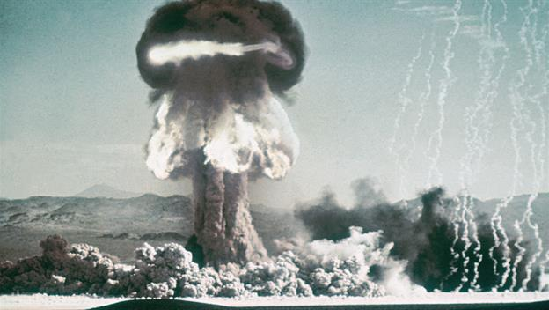

- Jul 16 1945 – WW2: The Heavy Cruiser USS Indianapolis (CA–35) leaves San Francisco with parts for the atomic bomb "Little Boy" bound for Tinian Island. This would be the last time the Indianapolis would be seen by the Mainland as she would be torpedoed by the Japanese Submarine I–58 on July 30 and sink with 880 out of 1,196 crewmen.
- Jul 16 1945 – WW2: the leaders of the three Allied nations, Winston Churchill, Harry S. Truman and Joseph Stalin, meet in the German city of Potsdam to decide the future of a defeated Germany.
- Jul 16 1950 – Korean War: Chaplain–Medic massacre – American POWs were massacred by North Korean Army.
- Jul 16 1960 – Cold War: USS George Washington a modified Skipjack class submarine successfully test fires the first ballistic missile while submerged.
- Jul 17 1898 – Spanish–American War: U.S. troops take Santiago de Cuba.
- Jul 17 1944 – Port Chicago disaster: Near the San Francisco Bay, two ships laden with ammunition for the war explode in Port Chicago, California, killing 320.

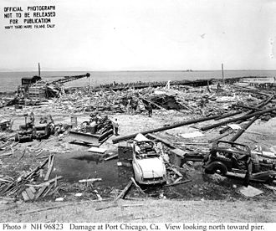
Cleaning up the damage at the remains of the pier.

- Jul 17 1944 – WW2: Napalm incendiary bombs are dropped for the first time by U.S. P-38 pilots on a fuel depot at Coutances, near Saint-Lô, France.
- Jul 17 1945 – WW2: The leaders of the three Allied nations, Winston Churchill, Harry S. Truman and Joseph Stalin, meet in the German city of Potsdam to decide the future of a defeated Germany.
- Jul 17 1966 – Vietnam: Ho Chi Minh orders a partial mobilization of to defend against American airstrikes.
- Jul 18 1863 – Civil War: Battle of Fort Wagner/Morris Island – the first formal African American military unit, the 54th Massachusetts Volunteer Infantry, fails in their assault on Confederate–held Battery Wagner. Casualties and losses: US 1,515 - CSA 174.
- Jul 18 1914 – The U.S. Congress forms the Aviation Section, U.S. Signal Corps, giving definite status to aircraft within the U.S. Army for the first time.
- Jul 18 1942 – WW2: German Me–262, the first jet–propelled aircraft to fly in combat, makes its first flight.
- Jul 18 1971 – Vietnam: New Zealand and Australia announce they will pull their troops out of Vietnam.
- Jul 19 1863 – Civil War: Morgan's Raid - At Buffington Island in Ohio, Confederate General John Hunt Morgan's raid into the north is mostly thwarted when a large group of his men (750) are captured in the Battle of Buffington Island while trying to escape across the Ohio River.
- Jul 19 1942 – WW2: Battle of the Atlantic - German Grand Admiral Karl Dönitz orders the last U-boats to withdraw from their United States Atlantic coast as a result of American anti–submarine countermeasures.
- Jul 20 1864 – American Civil War: Battle of Peachtree Creek - Near Atlanta, Georgia, Confederate forces led by General John Bell Hood unsuccessfully attack Union troops under General William T. Sherman. Casualties and losses: US 1,900 - CSA 2,500.
- Jul 20 1917 – WWI: Draft lottery held; #258 is 1st drawn.
- Jul 20 1944 – WW2: Adolf Hitler is wounded in an assassination attempt by German Army officers.
- Jul 20 1950 – Cold War: In Philadelphia, Pennsylvania, Harry Gold pleads guilty to spying for the Soviet Union by passing secrets from atomic scientist Klaus Fuchs.

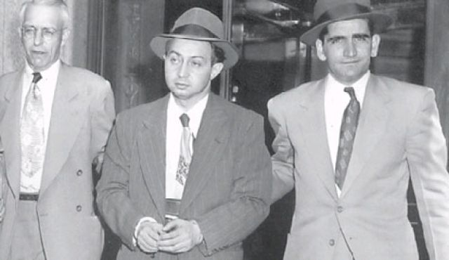
Harry Gold, center, being led into Federal Court, May 1950.

- Jul 20 1950 – Korean War: First engagement between United States and North Korean forces. The U.S. Army’s Task Force Smith is pushed back by superior forces in the Battle of Osan. Casualties and losses: US 163 - NKA 157.
- Jul 20 1964 – Vietnam War: Viet Cong forces attack the capital of Dinh Tuong Province, Cai Be, killing 11 South Vietnamese military personnel and 40 civilians (30 of which are children).
- Jul 20 1997 - The fully restored USS Constitution (aka Old Ironsides) celebrates her 200th birthday by setting sail for the first time in 116 years.
- Jul 21 1861 – Civil War: In the first major battle of the War, Confederate forces defeat the Union Army along Bull Run near Manassas Junction, Virginia. The battle becomes known as Manassas by the Confederates, while the Union calls it Bull Run. Casualties and losses: US 2,896 = CSA 1.892.
- Jul 21 1944 – WW2: U.S. Army and Marine forces land on Guam in the Marianas.
- Jul 21 1954 – Vietnam: The French sign an armistice with the Viet Minh that ends the war but divides Vietnam into two countries.
- Jul 22 1775 – American Revolution: George Washington took command of the Continental Army.
- Jul 22 1814 – Five Indian tribes in Ohio make peace with the United States and declare war on Britain.
- Jul 22 1942 – WW2: The United States government begins compulsory civilian gasoline rationing due to the wartime demands.
- Jul 22 1943 – WW2: Allied forces capture the Italian city of Palermo.
- Jul 22 1966 – Vietnam: B–52 bombers hit the DMZ between North and South Vietnam for the first time.
- Jul 22 1976 – Japan completes its last reparation to the Philippines for war crimes committed during the imperial Japan's conquest of the country in the Second World War.
- Jul 22 1987 – Gulf War: U.S. began escorting re–flagged Kuwaiti tankers in Persian Gulf.
- Jul 22 2003 – OIF: Members of 101st Airborne of the United States, aided by Special Forces, attack a compound in Iraq, killing Saddam Hussein's sons Uday and Qusay, along with Mustapha Hussein, Qusay's 14–year old son, and a bodyguard.
- Jul 23 1942 – WW2: The German offensives Operation Edelweiss and Operation Braunschweig begin.
- Jul 23 1944 – WW2: US forces invade Japanese–held Tinian.
- Jul 23 1962 – The Geneva Conference on Laos forbids the United States to invade eastern Laos.
- Jul 24 1814 – War of 1812: General Phineas Riall advances toward the Niagara River to halt Jacob Brown's American invaders.
- Jul 24 1864 – Civil War: Battle of Kernstown – Confederate General Jubal Anderson Early defeats Union troops led by General George Crook in an effort to keep them out of the Shenandoah Valley. Casualties and losses: US 590 - CSA 718.
- Jul 24 1943 – WW2: Operation Gomorrah begins: British and Canadian planes bomb Hamburg by night, those of the Americans by day. By the end of the operation in NOV. 9,000 tons of explosives killed 40,000-50,000 civilians leaving 1 million homeless and destroyed 280,000 buildings.

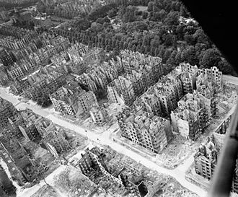
Typical bomb damage in the Eibek district of Hamburg, 1944 or 1945

- Jul 24 1990 – Gulf War: U.S. warships in Persian Gulf placed on alert after Iraq masses nearly 30,000 troops near its border with Kuwait.
- Jul 25 1783 – American Revolution: The war's last action, the Siege of Cuddalore, is ended by preliminary peace agreement. Casualties and losses: GB 1,000 - FR 1,000.
- Jul 25 1814 – War of 1812: Battle of Lundy's Lane – reinforcements arrive near Niagara Falls for General Riall's British and Canadian forces and a bloody, all–night battle with Jacob Brown's Americans commences at 1800; the Americans retreat to Fort Erie. Casualties and losses: UK/BC 878 - US 858.
- Jul 25 1861 – Civil War: The United States Congress passes the Crittenden–Johnson Resolution, stating that the war is being fought to preserve the Union and not to end slavery.
- Jul 25 1898 – After over two months of sea–based bombardment, the United States invasion of Puerto Rico begins with U.S. troops led by General Nelson Miles landing at the harbor of Guánica, Puerto Rico.
- Jul 25 1944 – WW2: Allied forces begin the breakthrough of German lines in Normandy.
- Jul 25 1946 – Cold War: Operation Crossroads: an atomic bomb is detonated underwater in the lagoon of Bikini atoll.
- Jul 25 1969 – Vietnam: U.S. President Richard Nixon declares the Nixon Doctrine, stating that the United States now expects its Asian allies to take care of their own military defense. This is the start of the "Vietnamzation" of the war.
- Jul 25 1990 – Gulf War: U.S. Ambassador tells Iraq, US won't take sides in Iraq–Kuwait dispute.
- Jul 25 2010 – Afghanistan: WikiLeaks published 75,000 classified documents about the War in Afghanistan, one of the largest leaks in U.S. military history.
- Jul 26 1861 – Civil War: George B. McClellan assumes command of the Army of the Potomac following a disastrous Union defeat at the First Battle of Bull Run.
- Jul 26 1863 – Civil War: Morgan's Raid ends – At Salineville, Ohio, Confederate cavalry leader John Hunt Morgan and 360 of his volunteers are captured by Union forces.
- Jul 26 1941 – WW2: in response to the Japanese occupation of French Indo–China, US President Franklin D. Roosevelt orders the seizure of all Japanese assets in the United States.
- Jul 26 1944 – WW2: USS Robalo (SS–273) sunk by a mine off western Palawan, Philippines. 74 killed, 4 POWs later died.
- Jul 26 1945 – WW2: The US Navy cruiser USS Indianapolis arrives at Tinian with parts of the warhead for the Hiroshima atomic bomb.
- Jul 26 1947 – Cold War: U.S. President Harry S. Truman signs the National Security Act of 1947 into United States law creating the Central Intelligence Agency, United States Department of Defense, United States Air Force, Joint Chiefs of Staff, and the United States National Security Council.
- Jul 27 1778 – American Revolution: First Battle of Ushant – British and French fleets fight to a standoff. Casualties and losses: GB 1,196 - FR 539.
- Jul 27 1861 – Civil War: Confederate troops occupy Fort Fillmore, New Mexico.
- Jul 27 1929 – The Geneva Convention of 1929, dealing with treatment of prisoners-of-war, is signed by 53 nations.
- Jul 27 1942 – WW2: Allied forces successfully halt the final Axis advance into Egypt.
- Jul 27 1944 – WW2: U.S. troops complete the liberation of Guam.
- Jul 27 1953 – Korea: Fighting in the Korean War ends when the United States, the People's Republic of China, and North Korea sign an armistice agreement. Syngman Rhee, President of South Korea, refuses to sign but pledges to observe the armistice.
- Jul 27 1964 – Vietnam: President Lyndon Johnson sends an additional 5,000 advisers to South Vietnam bringing the total number of United States forces in Vietnam to 21,000.
- Jul 27 1995 – The Korean War Veterans Memorial is dedicated in Washington, D.C.

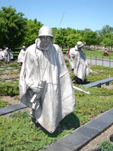

- Jul 28 1854 – USS Constellation (1854), the last all–sail warship built by the US Navy, is commissioned.
- Jul 28 1864 – Civil War: Battle of Ezra Church – Confederate troops make a third unsuccessful attempt to drive Union forces from Atlanta, Georgia.
- Jul 28 1914 – WWI: War begins when Austria–Hungary declared war on Serbia followed by Germany declaring war on France (3 AUG). On 4 AUG Germany invaded Belgium, Britain declared war on Germany, and President Woodrow Wilson declared policy of U.S. neutrality.
- Jul 28 1945 – A B–25 bomber crashes into the 79th floor of the Empire State Building in New York City, killing 14 and injuring 26.
- Jul 28 1965 – Vietnam: U.S. President Lyndon B. Johnson announces his order to increase the number of United States troops in South Vietnam from 75,000 to 125,000.
- Jul 29 1862 – Civil War: Confederate spy Belle Boyd was arrested by Union troops after her lover turned her in.
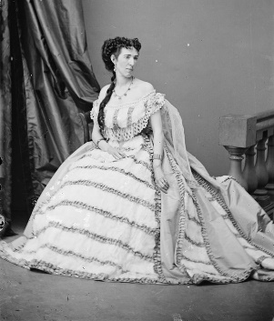

- Jul 29 1915 – U.S. Marines land at Port–au–Prince to protect American interests in Haiti.
- Jul 29 1950 – Korean War: After four days, the No Gun Ri Massacre ends when the US Army 7th Cavalry Regiment is withdrawn. The U.S. Army cites the number of South Korean refugee casualties as "unknown."
- Jul 29 1965 – Vietnam War: the first 4,000 101st Airborne Division paratroopers arrive in Vietnam, landing at Cam Ranh Bay.
- Jul 29 1967 – Vietnam: The aircraft carrier USS Forrestal in Gulf of Tonkin is hit by a series of chain-reaction explosions caused by an unusual electrical anomaly on its flight deck, Casualties and losses: 134 killed, 161 injured, $100 million damage.

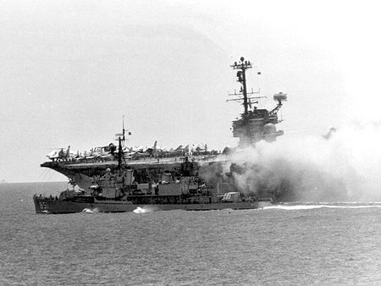
USS Forrestal on fire, the worst US carrier fire since WWII; USS Rupertus (DD-851) maneuvers to within 20 ft to use fire hoses.

- Jul 30 1863 – Indian Wars: Chief Pocatello of the Shoshone tribe signs the Treaty of Box Elder, agreeing to stop the harassment of emigrant trails in southern Idaho and northern Utah.
- Jul 30 1864 – Civil War: Battle of the Crater – Union forces attempt to break Confederate lines at Petersburg, Virginia by exploding a large bomb under their trenches. Casualties and losses: US 3,798 - CSA 1,491.
- Jul 30 1919 – USS G–2 (SS–27) foundered and sunk in Long Island Sound. 3 died.
- Jul 30 1942 – FDR signs bill creating women's Navy auxiliary agency (WAVES).
- Jul 30 1944 – WW2: U.S. 30th division reaches suburbs of St–Lo Normandy.
- Jul 30 1945 – WW2: After delivering parts of the first atomic bomb the U.S. cruiser Indianapolis is torpedoed and sunk by Japanese submarine I-58. 880 die.
- Jul 31 1777 – American Revolution: The U.S. Second Continental Congress passes a resolution that the services of Marquis de Lafayette "be accepted, and that, in consideration of his zeal, illustrious family and connections, he have the rank and commission of major–general of the United States.
- Jul 31 1813 – American Revolution: British invade Plattsburgh NY.
- Jul 31 1942 – WW2: USS Grunion (SS–216) sunk by gunfire from torpedoed Japanese transport Kashima Maru; 10 miles north Segula, near Kiska Island, Aleutians. 70 killed.
- Jul 31 1948 – USS Nevada (BB-36) is sunk by an aerial torpedo after surviving hits from two atomic bombs (as part of post-war tests) and being used for target practice by three other ships.
- Jul 31 1991 – Senate votes to allow women to fly combat aircraft.

[Source: Various July 2018 ++]

